GEOMETRICAL OPTICS

Remember to photocopy 4 pages onto one sheet by going A3→A4 AND back to back on the photocopier

Student name: ________________________________

This booklet contains every higher and ordinary level question that has appeared on an exam paper on this topic from 2002–2023
Worked solutions to Ordinary Level Maths questions can be found at the end of the booklet.
Fully worked solutions to all higher level past papers can be found on the homepage of thephysicsteacher.ie

Screencasts of all topics plus a wide range of other resources via this link

You can find this document plus all other booklets on the homepage of thephysicsteacher.ie
Last updated: 04/08/2024
Noel Cunningham
Contents
Introduction to the science of learning 3
The science of learning quiz: Part 1 4
1. PLANE MIRRORS 7
Student Notes 9
Laws of reflection of light 9
How our brain determines the position of an object 10
How an image is formed in a plane mirror 11
Cool illusions 12
The science of learning quiz: Part 2 14
2. CURVED MIRRORS 16
Concave mirrors – ray diagrams 16
Uses of concave mirrors 18
Convex mirrors – ray diagrams 19
Uses of convex mirrors 19
Image formation - maths problems 20
Magnification 22
Magnification maths problems 22
MEASUREMENT OF THE FOCAL LENGTH OF A CONCAVE MIRROR 24
SLOP 26
Exam questions Mirrors 2002 – 2023 28
Ordinary level 28
Higher level 30
The science of learning quiz: Part 3 31
3: REFRACTION 33
Laws of refraction of light 34
Critical angle 35
Relationship between critical angle and refractive index 36
Using a prism to turn a ray of light through (i) 90⁰ (ii) 180⁰ 38
Applications of total internal reflection 38
Optical fibres 39
Refractive index in terms of the speed of light in different media 40
A crash course on scientific notation 41
Refractive index in terms of real depth and apparent depth 44
Summary of formula 46
VERIFICATION OF SNELL’S LAW OF REFRACTION 47
SLOP 51
Exam questions Refraction 2002 – 2023 52
Ordinary level 52
Higher level 53
Exam questions Optical fibres 2002 – 2023 54
Ordinary level 54
Higher level 55
The science of learning quiz: Part 4 56
4: LENSES 58
Why does a converging lens cause light to converge? 58
Convex (converging) lenses - ray diagrams 59
Concave (diverging) lenses - ray diagrams 60
Maths Problems 61
The eye 63
Power of a lens 66
Power of two lenses – maths questions 66
Power of two lenses: The eye plus corrective lens 67
MEASUREMENT OF THE FOCAL LENGTH OF A CONVEX LENS 69
SLOP 72
Exam questions Lenses 2002 – 2023 73
Ordinary level 73
Higher level 75
Exam solutions 2002 - 2022: Ordinary level maths parts only 77

Introduction to the science of learning

Isn’t it strange that despite students being in a learning environment between the ages of 4 and 24, teaching students how to learn isn’t a core part of classroom teaching at all levels?

[I]t is entirely possible for someone to qualify as a teacher and have no knowledge about recent, and even not so recent, advances in cognitive psychology"
Professor Dylan Wiliam

From the time a child enters school until she earns a diploma, her principal task is to learn new facts and skills. It would seem natural, therefore, that somewhere along the way (perhaps around sixth grade or so, when schoolwork really becomes demanding) she would be told something about how her memory works—and something about how to make it work better. But that rarely happens. In fact, most college students report that they have improvised their own systems of study.
Professor Daniel T Willingham
link

“There is an overwhelming assumption in our educational system that the most important thing to deliver to students is content” (p. 341, italics in original). One concern here is that students who do well in earlier grades, in which learning is largely supervised, may struggle later, when they are expected to regulate much of their own learning, such as in high school or college. Teaching students to use these techniques would not take much time away from teaching content and would likely be most beneficial if the use of the techniques was consistently taught across multiple content areas, so that students could broadly experience their effects on learning and class grades.
link

The secret to continued improvement, it turns out, isn’t the amount of time invested but the quality of that time. It sounds simple and obvious enough, and yet so much of both our formal education and the informal ways in which we go about pursuing success in skill-based fields is built around the premise of sheer time investment.
link

Why should I learn about the science of learning in Physics class?
The word “truthiness” was coined to describe an intuitive feeling that an idea just “feels right,” even if there is in fact no evidence for it. Ineffective study techniques are a perfect example of this; they feel so right that we think they must be useful. Unfortunately not.

There are just a two key ideas that I want you to learn from this series of lessons:
- What constitutes effective study (and why).
- What constitutes ineffective study (and why).

Any good study habits you pick up this year will stand to you not only as you prepare for your leaving cert but also in college. The dropout rate in college is one of our well-kept secrets but is due, at least in part, to our inability to study properly. We can survive this problem in secondary school where we get lots of help from our teachers. But in college you can find yourself completely on your own so if you don’t pick up good habits before you get there it can be very difficult to survive their end-of-year exams. And as you probably know by now, few teachers teach you those skills in your normal classes and you’re not likely to learn them from a one-off ‘Study-Skills’ seminar either. So this may well be your one and only opportunity to learn about how we learn. Rather than smother you with information now, I will instead drip-feed it to you, adding a little to each physics chapter as we go along. I am taking most of this information from the following googledoc, so feel free to read ahead yourself if you are up to the challenge.
The science of learning googledoc

The science of learning quiz: Part 1

One of the least well-known study techniques is known as ‘pre-testing’. It turns out that if you take a test even before you study the material it seems to prime the brain so that it recognises and pays more attention to the concepts when it encounters them again in the normal fashion. So we’re going to apply that here. You’re going to attempt each of the questions below. You need to write down your best guess for each question (even if you have absolutely no idea what it’s about) and after you have attempted them you can check your answers on the next page.

What if we could remember everything?

- What is amnesia?

- What is hyperthymesia?

How we make memories
Many of the concepts we will be discussing later are introduced in the following CrashCourse 10 minute YouTube video, so you should try the following questions, then watch the video and try the questions again.
https://www.youtube.com/watch?v=bSycdIx-C48

- In the later 1960’s American psychologists Richard Atkinson and Richard Shiffrin discovered that memory formation can be divided into three different stages. Name each stage and explain each term.

- How long does information typically remain in short term memory (if there is no engagement with it)?

- How many distinct pieces of information can your brain hold at any one time (approximately)?

- What is the difference between short-term memory and working memory?

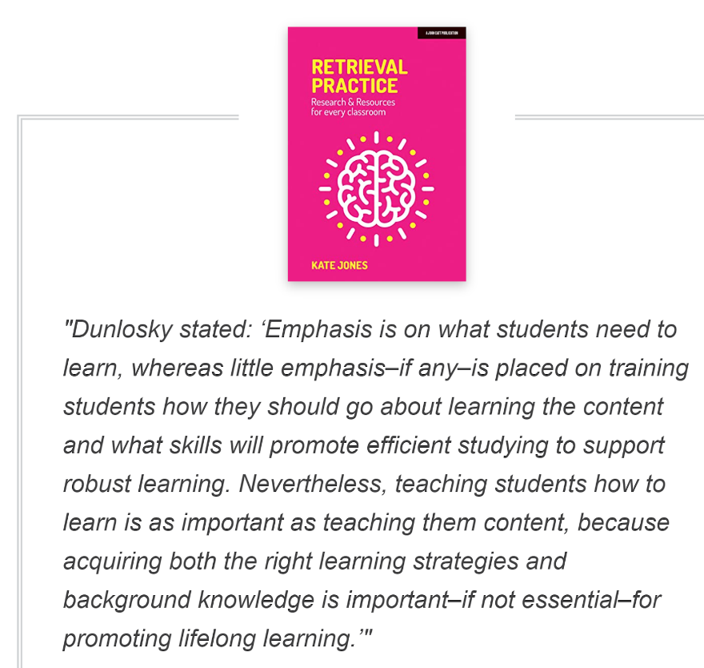

Answers

What is amnesia?
Amnesia is the inability to form new memories or retrieve existing memories.

What is hyperthymesia?
“If we remembered everything, we should on most occasions be as ill off as if we remembered nothing”.
William James

The word "hyperthymesia" derives from Ancient Greek: hyper- ("excessive") and thymesis ("remembering"). Hyperthymesia is a condition that leads people to be able to remember an abnormally large number of their life experiences in near perfect detail. In case you think this is cool, it isn’t. We have evolved brains that forget for good reason.
The woman who could not forget - 6 minute YouTube video
So the challenge is to teach our brain to forget what we don’t need and to remember what we do need. It would be nice if the rule it used was; “remember what I want to remember” but unfortunately that’s not it. If it was then we wouldn’t keep forgetting our passwords or whether or not we turned on the alarm as we left the house. So how does it decide what information to keep and what to discard?
Stay tuned.
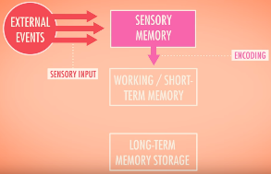

Memory formation can be divided into three different stages. Name each stage and explain each term
Encoding the information into the brain: getting it into the brain’s short term memory.
Storing the information for future use in the brain’s long term memory.
Retrieving the information: getting it back out from the brain’s long term memory.

How long does information typically remain in short term memory for?
30 seconds. What implications does this have for how you study?

How many distinct pieces of information can your brain hold at any one time (approximately)?
Between 4 and 7. What implications does this have for how you study?

What is the difference between short-term memory and working memory?
The short answer is that it’s not clear; experts refer to one or the other depending on what they’re trying to explain. A rough explanation would be that short term memory refers to the storing of information, whereas working memory refers to the storing of both information and procedures (how to ‘do’ things).
A more detailed explanation from a psychology paper is here

Okay – back to physics for now . . .

1. PLANE MIRRORS

Something to think about

The problem with our education is that we educate our students just enough to believe what they are taught, but not enough to question what is taught.

- A mirror is made of glass, but light travels through glass so how can it act as a mirror?
- Draw a diagram of a book sitting on a table with a stick person standing on the floor beside the table, and a light-bulb higher up.
Show, using arrowed lines on the diagram, how the person sees the book.

- Imagine that the book in the previous question is a blue book and that there’s a lightbulb shining on it which emits white light. Why does the book appear blue?

- When both you and your friend look at the same blue book, is there any way to show that both you and your friend see the same colour?

- Why does shoe polish (a yucky mucky substance) make your shoes shiny?

- Did you know that you can look back in time (in fact you’re doing so right now)? Explain how.

- Is it possible to build an instrument which would allow you to see yourself being born – or conceived?

- How far away would this instrument have to be in order to allow you to see dinosaurs roaming the Earth?

- You must have noticed that if it’s dark outside and you are in a bright room looking out through a window that the window itself acts like a mirror. What’s going on here?

- You have never actually your own face, only a reflection or a picture of it.
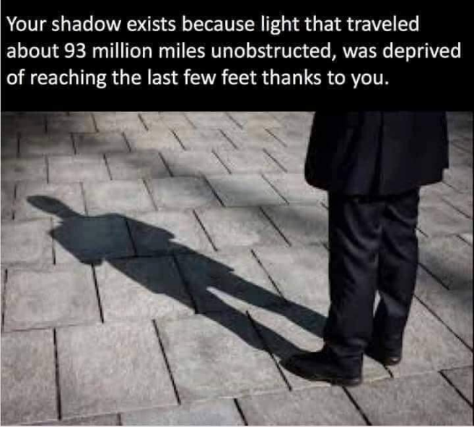
The hardest part of learning physics is accepting what Terry Prachett called ‘lies to children’. It means that almost none of what we teach you is the correct answer, but rather a watered-down version which has been simplified to the extent that it becomes teachable. In fact sometimes our explanations are so far offside that they shouldn’t even be allowed in print. If you ask a physics teacher where all the energy in the world comes from you will probably be told something about the ‘Big Bang’. But that’s not a proper answer and if anything it only begs the follow-up question ‘Where did the Big Bang’ come from?’, for which there is a very simple but (for many) unpalatable answer: we have absolutely no flucking idea. Personally I don’t mind that we don’t know. The fun is in trying to find out. The sin is in pretending that the superficial answer is all there is to it. Your job is to know when you are being fobbed off with a half-assed answer. Like this one:
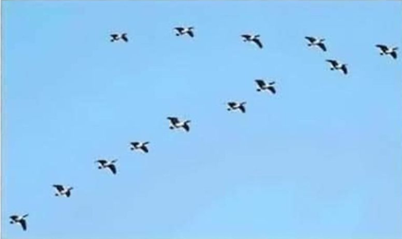
Ever notice that when geese fly in a V formation, one side is always longer than the other. Why is that?
Answer: Because there are more geese on one side.

Einstein spotted this quite early in his schooling. And he hated it;
It bored me. The teachers behaved like sergeants. I wanted to learn what I wanted to know, but they wanted me to learn for the exam. What I hated most was the competitive system there, and especially sports. Because of this, I wasn't worth anything, and several times they suggested I leave. This was a Catholic School in Munich. I felt that my thirst for knowledge was being strangled by my teachers; grades were their only measurement.

You go talk to kindergartners or first-grade kids, you find a class full of science enthusiasts. They ask deep questions. They ask, "What is a dream, why do we have toes, why is the moon round, what is the birthday of the world, why is grass green?"
These are profound, important questions. They just bubble right out of them.
You go talk to 12th graders and there's none of that. They've become incurious. Something terrible has happened between kindergarten and 12th grade. ~ Carl Sagan

Student Notes

Objects that emit light are known as luminous objects, while those which we can only see due to light reflecting off of them are known as illuminated objects.

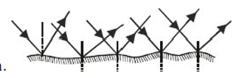
Reflection is defined as the bouncing of light off an object

When light hits off most everyday objects it scatters in all directions – this is known as irregular or diffuse reflection.

When light strikes a flat and silvered surface – a plane mirror – then the reflection is known as regular or specular reflection and this reflected light behaves in a much more predictable way. In fact we can say two things for definite about this reflected light, these are known as ‘The laws of reflection of light’.

Laws of reflection of light
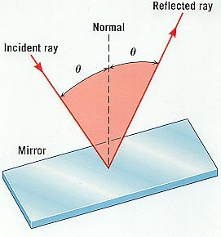
- The incident ray, the normal at the point of incidence and the reflected ray all lie on the same plane.

- The angle of incidence is equal to the angle of reflection.
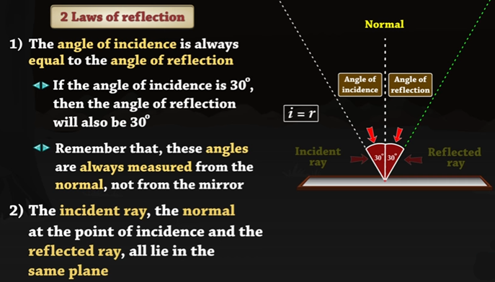
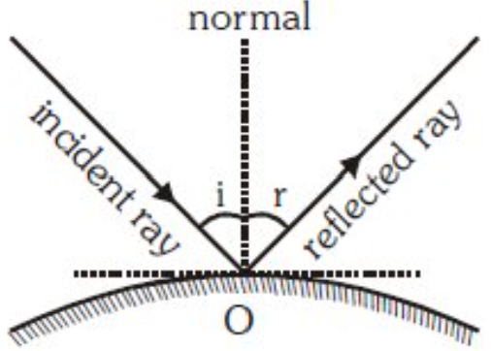

How our brain determines the position of an object
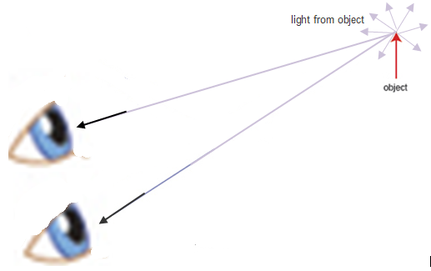
Stereoscopic binocular vision
Light rays reflect outwards in all directions – they are diverging as they travel outwards. Two such rays strike a person’s eyes as shown. The eye/brain combination somehow manages to work out the direction that the rays are travelling at relative to each other and can then work out how far back the rays must have been in order to converge. The brain then ‘puts’ the image in that position.

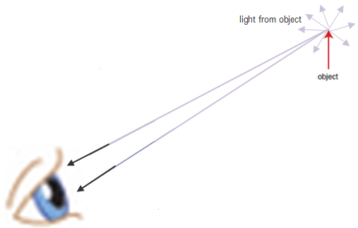
Even more impressive is that the same process works on just one eye (monocular vision) – see the image below for how this works.

You can demonstrate this for yourself as follows:
Hold one hand at arm’s length (horizontally) with the index finger pointing upwards.
Hold your other hand up high with the index finger pointing downwards. Now quickly drop the top finger so that it lands on the bottom one. Not too difficult? Now close one eye and repeat. It’s much trickier. It’s impressive that we can do it at all when you think about it. But then I don’t suppose you have ever thought about it. A variation is to place an object on a table about a metre in front of you, then cover one eye and reach out to touch it - you quite often miss by several cm. Open both eyes and you have no problem locating it.

In all the diagrams from now on I’m going to just have light rays going into one eye rather than two (to keep the diagrams as simple as possible). Interestingly most textbooks don’t include any reference to an eye whatsoever, making the whole process of what’s going on even more confusing. This is partly because the early years of science represented an attempt to separate the nature of reality from the observer, as though the former would exist without the latter. When it comes to vision however it is simply not possible to have a complete explanation without reference to the observer.
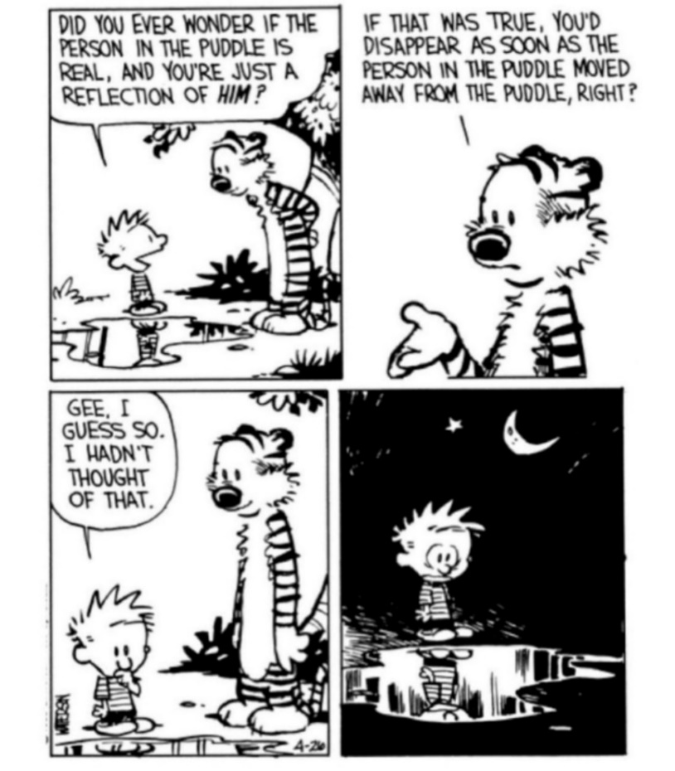

By the way, did you know that over one billion birds die in the US each year from crashing into glass windows? Never, ever wash your windows.
Just to put this in perspective, cats kill about 2.4 billion and it is estimated that one million die from wind turbines.

How an image is formed in a plane mirror
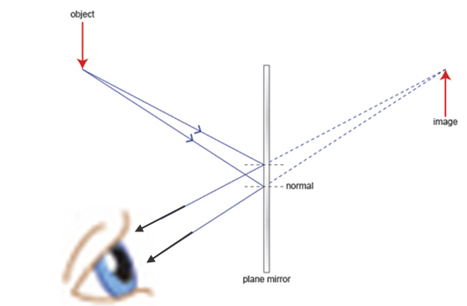

The image formed by a plane mirror is called a ‘virtual image’.

For a plane mirror, the (virtual) image is as far behind the mirror as the object is in front.
This is really, really cool.
If this seems silly because you reckon that nobody thinks an image is ‘behind’ a mirror, then just look up ‘animals and mirrors’ on YouTube. One such documentary shows a scientist placing a a full-length mirror against a tree and waiting to see what the response would be. The first chimp to see it immediately thought there was another animal behind the mirror and poked its head around to see. When it couldn’t find anyone it became confused but quickly tired of the puzzle and resumed its previous activities. Try this yourself at home if you have a young sibling or cousin to act as guinea pig.

So what’s really going on here? Well consider rays of light coming from the object and bouncing off the mirror and into the viewer’s eye. The rays are diverging as they enter the eye so if or until your brain realises that there’s a mirror involved, it will consider that the object lies at the position of intersection of the rays of light – which in this case will always be behind the mirror. Your brain is being fooled! Because of the geometry involved, the rays appear to intersect as far behind the mirror as the object is in front.

Cool illusions
Illusions are a result of your brain taking shortcuts in order to quickly make sense of the information it receives so we shouldn’t be surprised that we get fooled every now and again. If anything it’s actually impressive that what we ‘see’ seems to correspond with reality as often as it does!
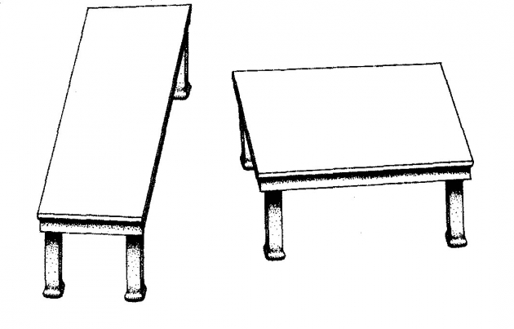

These 2 table-tops are identical in size and shape:
https://en.wikipedia.org/wiki/Shepard_tables


This popular photo by Terri Babers is an example of how optical illusion mess with your mind. First you see a man running into the snow and then...
Link

How many faces do you see in this picture?
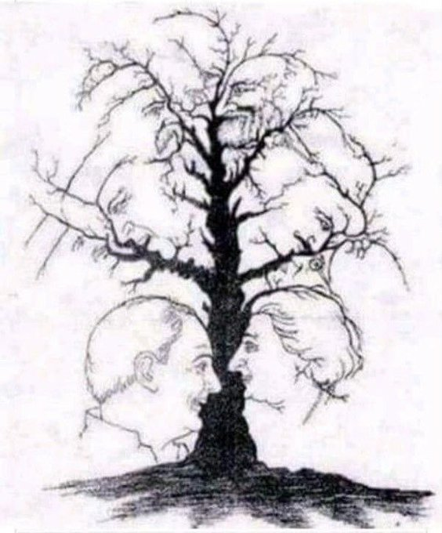

The science of learning quiz: Part 2

- What are the greatest misconceptions that students (and many parents) have about learning?

- Many of us believe that our memory is like a video tape. List three crucial differences (in relation to storing information) between a video tape and our memory.

- So we believe that our memory is like a videotape when it turns out that it’s now - who cares?

Answers

What are the greatest misconceptions that students (and many parents) have about learning?
- Study is study
OR
- It doesn’t matter how you study
OR
- All that matters is how long you spend studying

By the way, why is this idea (that all that’s important is the time spent studying) so pervasive?
Here’s one possibility:
Max Weber was a protestant who championed the idea that working was a means of paying homage to God and so was itself a form of prayer. As a result, the idea of a ‘Protestant work ethic’ was born whereby work for its own sake would be rewarded and working hard in this life will lead to eternal reward in the next. This in turn implies that what is important is the quantity of the work, and not necessarily the quality.
It might be a bit of a stretch but this seems to be the same quasi-religious belief which underlies our approach to how we study; except that we now know from decades of research in this area that it is very definitely not so. Yes you need to work hard, but your brain has very definite rules regarding whether or not to store information, and if you’re not following those rules then any amount of hard work won’t help.

Many of us believe that our memory is like a video tape. List three crucial differences (in relation to storing information) between a video tape and our memory.
- The act of retrieving information from your long term memory makes it easier to recall again in the future. This obviously doesn’t happen with a video-tape (5:00 in the video below).
- A video tape has limited capacity. Your long-term memory has almost infinite capacity and the more you learn the more space you create because you are storing concepts that can be used to create links to further related information (4:00 in the video below).
- The information in your brain is dynamic, not static. This means that it is continually subject to manipulation and every time you retrieve information from long term memory you are actually altering it in some way. This is why it is impossible to have a 100% accurate memory of an event (and also partly explains why eyewitnesses to a crime are often so unreliable. And of course this is exasperated by the fact that the witness thinks that their memory is accurate.) (1:15 in the video below).
Why your memory is not like a video tape. YouTube interview with Professor Robert Bjork
You could stop the video at 5:30. Alternatively the rest should reinforce concepts covered elsewhere.

So we believe that our memory is like a videotape when it turns out that it’s now - who cares?

You do - or at least you should. If you wanted to capture a given piece of text on a video tape then you would simply run your video camera over all the text and you’re done. If you believe that your memory works in the same way then you’re likely to think that in order to memorise information you just need to read over it (or highlight it). This also highlights (sorry) why the question “how many chapters have you covered (or ‘gone over’?)” is meaningless. You could have ‘gone over’ the entire course and still remember absolutely none of it.
The image is a still taken from a short video of twitter of the kid trying to ‘scoop’ all the information from the page into his brain before then turning the page and repeating.
We may laugh at how silly this is, but the practice of believing that your brain will store the information just because you read it isn’t much different.
link

Okay – back to the wonderful world of physics for now . . .

2. CURVED MIRRORS

Student Notes

There are two types of curved mirror; concave and convex.
A concave mirror curves away from the observer (and is shaped like a cave) whereas a convex mirror bulges outwards towards the observer.
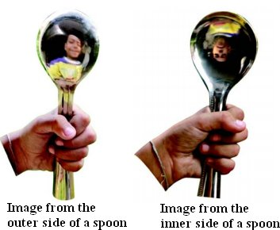

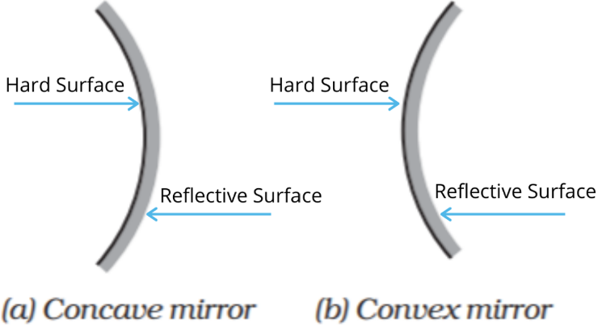

Concave mirrors – ray diagrams

Why is the image in the first spoon the right way up (upright) while the image in the second spoon is upside down (inverted)? Well rays of light which strike a concave mirror reflect back in a predictable way. We use three simple rules to help us see what an image will look like when viewed through a mirror. Once again the position where these lines intersect represents the position of the image (or, in the case of a virtual image, where the brain thinks the image is located; we will explain the terms real image and virtual image shortly).

You should be able to draw a ray diagram showing how a concave mirror forms an image of an object which is placed:
- outside the focus – resulting in a real image
- inside the focus – resulting in a virtual image

For each of the following make sure to label the centre of curvature (C), the focus (f), the Object and the Image.
Note that the focus is half-way between the centre of curvature and the mirror

Drawing the diagrams

Three rules (we only need to use two for any particular image formation):
- A ray of light travelling parallel to principal axis will reflect back through the focus.
- A ray of light hitting the mirror at in the intersection of the the principle axis and the mirror itself will reflect back out at an equal angle below the principal axis.
- A ray of light passing through the focus will reflect back out parallel to the principal axis.
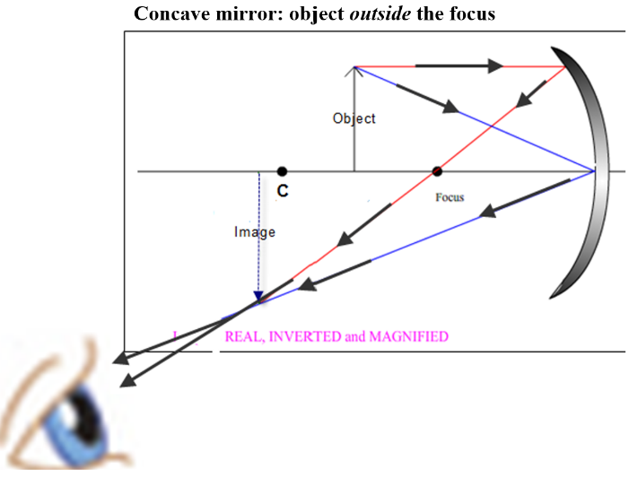

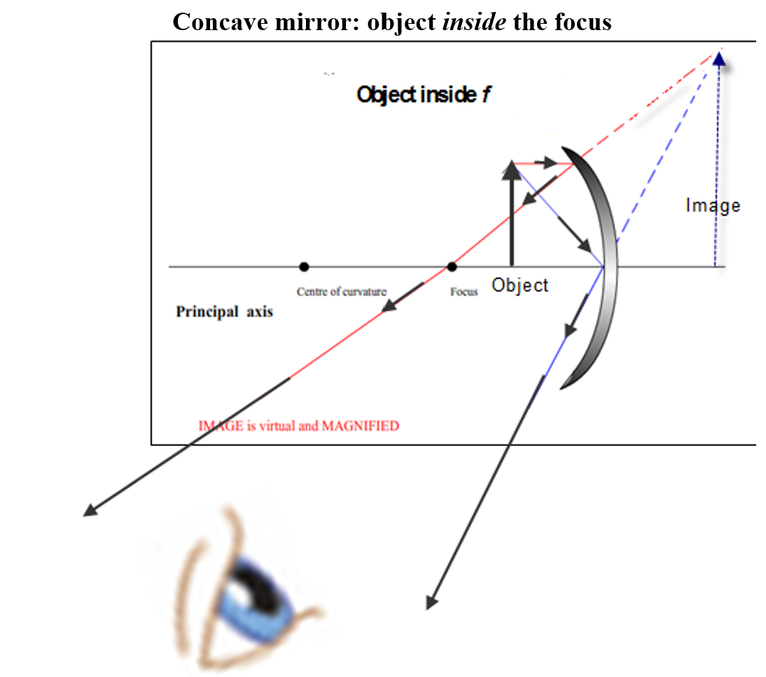

Notice that when the object is inside the focal point the light rays never intersect, but from the viewer’s perspective they appear to do so behind the mirror.

Real and virtual images
A real image is an image formed by the actual intersection of light rays.
A real image can be located on a screen.

A virtual image is formed by the apparent intersection of light rays.
A virtual image cannot be formed on a screen (because there are no actual rays to intersect behind the mirror)
Note
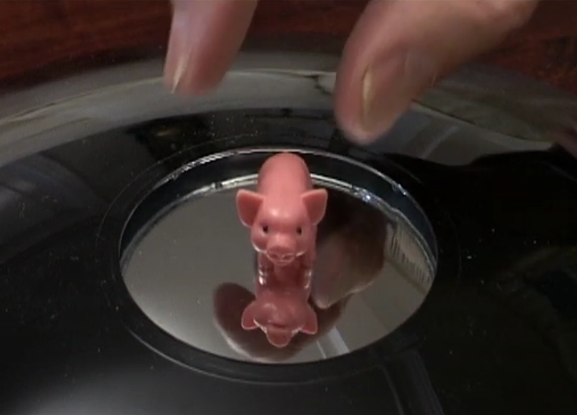
A real image is always in front of the mirror and inverted.
A virtual image is always behind the mirror and upright.

This is a wonder example of a real image.
Just google ‘pig mirage’ (although it’s definitely not a mirage). The image is a three-dimensional real image sitting in the air.

Uses of concave mirrors
- Searchlights
- Floodlights
- Headlights in a car
- Solar mirrors
- Cosmetic mirrors

Lenses and mirrors: ignite paper by placing paper (ignition of bugs is not condoned!) at the focal point. This is only likely to work on a sunny day with no wind.

Convex mirrors – ray diagrams

Here only one diagram is needed; the image is always diminished, upright and virtual.

Two Rules
- A ray travelling from the top of the object to mirror - parallel to principle axis - reflects back as if coming from the focus on the other side.
- A ray travelling from the top of object which strikes the mirror at the intersection of the mirror and the principle axis will reflect back at an equal angle on the other side of the principle axis.
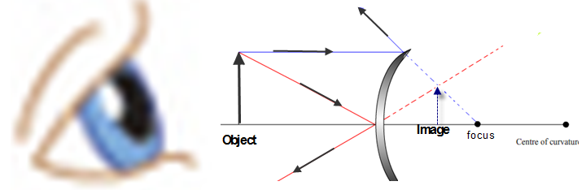

Notice that in this situation (similar to the concave mirror when the object is inside the focus) the light rays never intersect, but from the viewer’s perspective they appear to do so behind the mirror.
The image is therefore always virtual, regardless of where the object is placed.

2023 Deferred Higher Level  A person holds a curved metal spoon at arm’s length and rotates it slowly. On one side of the spoon the image seen is inverted and on the other side the image is upright. Explain why. | Concave side always gives an inverted image as long as the object is outside the focal length.  Convex side always gives an upright image

Uses of convex mirrors
- Door mirror of a car
- In shops to deter shoplifters
- At concealed entrances to give a view of oncoming traffic

All of these are based on the principle that a convex mirror gives a wide field of view, even if does give a diminished image.

Image formation - maths problems
To fully understand Physics you first need to understand the language of physics – which happens to be maths. It would not be possible to understand the universe without it and if anything this course gives quite a false impression of what a college course in physics looks like. There is much less English and much (much, much) more maths.
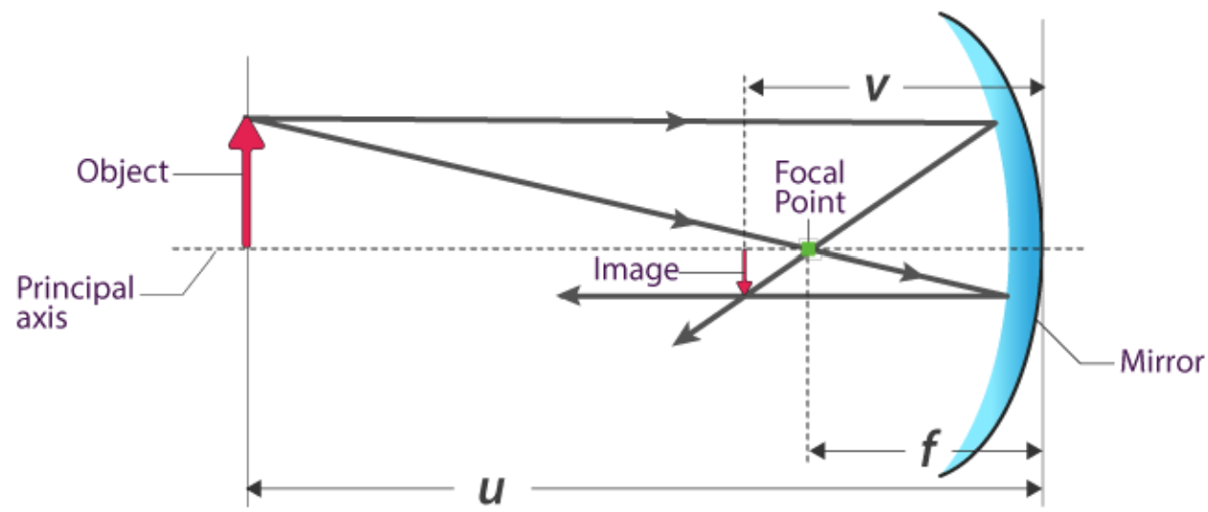
In fact to this day scientists and (mostly) philosophers debate whether or not maths was discovered or invented.

Relationship between focal length (f), object distance (u) and image distance (v) for spherical mirrors
$$\frac{1}{f}=\frac{1}{u}+\frac{1}{v}$$

Convention
For a concave mirror f is positive
For a convex mirror f is negative

If you are looking for v and it turns out to be positive, it means that the image is a real image.
If you are looking for v and it turns out to be negative, it means that the image is a virtual image.

This is referred to as the real is positive convention (think ‘RIP’).

2004 Question 12 (b) [Ordinary Level]
A concave mirror has a focal length of 20 cm. An object is placed 30 cm in front of the mirror.
How far from the mirror will the image be formed?
focal length f = 20 cm  object distance u = 30 cm  image distance v = ? | $\frac{1}{f}=\frac{1}{u}+\frac{1}{v}$ $\frac{1}{20}=\frac{1}{30}+\frac{1}{v}$ $\frac{1}{20}-\frac{1}{30}=\frac{1}{v}$ $\frac{1}{60}=\frac{1}{v}$ Answer: v = 60 cm
2005 Question 5 [Higher Level]
An object O is placed 30 cm in front of a concave mirror of focal length 10 cm. How far from the mirror is the image formed?

focal length f = 10 cm  object distance u = 30 cm  image distance v = ? | $\frac{1}{f}=\frac{1}{u}+\frac{1}{v}$ $\frac{1}{10}=\frac{1}{30}+\frac{1}{v}$  $\frac{1}{10}-\frac{1}{30}=\frac{1}{v}$ $\frac{2}{30}=\frac{1}{v}$  ⇒ v = 15 cm = 0.15 m

2014 Question 12 (b) [Higher Level]
A person looks at her image in a shiny spherical decoration when her face is 30 cm from the surface of the decoration. The diameter of the decoration is 20 cm.
Find the position of the image.
Solution
Note that the focus is half-way between the centre of curvature and the mirror.
The diameter of the decoration is 20 cm so the radius is 10 cm.
Therefore the centre of curvature is 10 cm from the mirror. Therefore f = 5 cm.

And just in case that’s not enough, note also this is a convex mirror so we need to make f negative.

f = -5 cm  u = 30 cm  v = ? | $\frac{1}{f}=\frac{1}{u}+\frac{1}{v}$ $\frac{1}{-5}=\frac{1}{30}+\frac{1}{v}$ $-\frac{1}{5}-\frac{1}{30}=\frac{1}{v}$ $-\frac{7}{30}=\frac{1}{v}$  v = $-\frac{30}{7}$ = - 4.3 cm  The negative sign for v indicates that the image is virtual

Magnification
Magnification refers to the ratio between the height of the image and the height of the object. If the image is 2 times higher than the object then the magnification is 2. It turns out that ratio of image height to object height is the same as the ratio of the image distance to the object distance so we can use this to work out the magnification if we need to.
$$M=\frac{image height}{object height}= \frac{v}{u}$$

The diagram below (which you don’t need to know) illustrates why the ratio between image height h_{i} and object height h_{o} is equal to the ratio between the image distance (labelled i here) and the object distance (labelled o here).
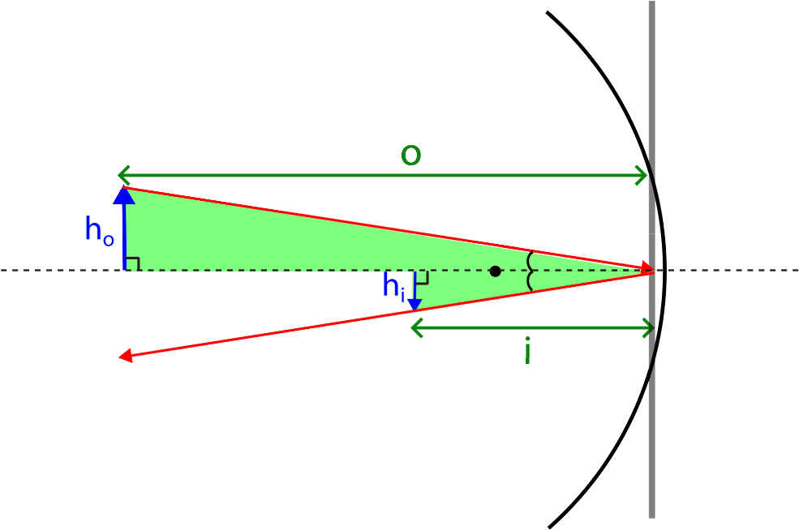

Magnification maths problems

2021 Question 10 [Ordinary Level]
An object of height 2 cm is placed 17 cm in front of a concave mirror.
An image with a height of 3 cm is formed.
- Calculate the magnification.
- Calculate the image distance.

Image height = 3 cm  Object height = 2 cm  M = ? | $$M=\frac{image height}{object height}= \frac{3}{2}=1.5$$
Object distance u = 17 cm  M = 1.5  v = ? | $M= \frac{v}{u}$ (M)(u) = v (1.5)(17) = v v = 25.5 cm

2017 Question 12 (c) [Higher Level]
It has been recently suggested that the 17th century Dutch artist Rembrandt used a concave mirror to help him etch self-portraits by projecting an inverted image of himself onto a copper sheet.
Rembrandt used a concave mirror of focal length 60 cm so that the image on the copper sheet was only half the size of the object.
- Calculate the distance from the sheet to the mirror.
- Calculate the distance from the object to the mirror.

f = 60 cm  M = ½  v = ? | Calculate the distance from the sheet to the mirror.  $M=\frac{image height}{object height}= \frac{v}{u}$ $= \frac{1}{2}$ u = 2v  $\frac{1}{f}=\frac{1}{u}+\frac{1}{v}$ $\frac{1}{60}=\frac{1}{2v}+\frac{1}{v}$ $\frac{1}{60}=\frac{3}{2v}$ v = 90 cm
Calculate the distance from the object to the mirror.
u = 2v u = 180 cm

Question: Why did the farmer call his ranch “The focal point”?
Answer: It was the place where the sons raise meat
Think about it.

MEASUREMENT OF THE FOCAL LENGTH OF A CONCAVE MIRROR

APPARATUS: Concave mirror, screen, lamp-box with crosswire, metre stick, retort stand.
DIAGRAM

Procedure

First find an approximate value for the focal length
Use a concave mirror to focus the image of a distance object onto a screen. Measure the distance between the mirror and the screen. This distance is approximately the same as the focal length.
Now proceed as outlined below.
- Place the ray-box well outside the approximate focal length.
- Move the screen until a clear inverted image of the crosswire is obtained.
- Measure the distance u from the crosswire to the mirror, using the metre stick.
- Measure the distance v from the screen to the mirror.
- Repeat this procedure for different values of u.
- Calculate the focal length of the mirror using the formula and get an average.

RESULTS
Object distance u
Image distance v

Focal Length f

Average value for focal length f = ________ cm

SOURCES OF ERROR / PRECAUTIONS
- Determining when the image was in sharpest focus; repeat each time and get an average.
- Parallax error associated with measuring u and v; ensure your line of sight is at right angles to the metre stick.
- Take all measurements from the back of the mirror.
Related exam questions

Higher Level: 2019, 2013, 2007 Ordinary Level: 2015, 2010, 2002

The following is part of a student’s report of an experiment to measure the focal length of a concave mirror.
“I placed an object at different positions in front of the mirror so that a real image was formed in each case.” The table shows the measurements recorded by the student for the object distance u and the image distance v.

Calculate the value for the focal length f of the mirror using the data.

u (cm) | 20.0 | 30.0 | 40.0 | 50.0
v (cm) | 61.0 | 29.5 | 24.0 | 20.5
f (cm)

Theory questions

Draw a labelled diagram showing how the apparatus was arranged.
Mark the distances u and v on your diagram.

How was an approximate value for the focal length found? | An image of a distant object was focused on a screen.  Measure the distance from the screen to the mirror.
What was the advantage of finding the approximate value for the focal length? | To avoid placing object inside f during the experiment) which would have meant that the image couldn’t be formed on the screen.  OR so a real image could be formed
Describe how the student found the position of the image. | The position of the screen was adjusted until the image of the cross-wires came into focus.
Explain why the student was unable to form an image on the screen when the object was close to the mirror. | The object was inside the focal length so only a virtual image formed (which can’t be formed on a screen).
Why did the student repeat the experiment? | To improve the overall accuracy
Give two precautions that should be taken when measuring the image distance. | Avoid parallax error when measuring distances, measure to back of mirror, sharp image formed

Solution
u (cm) | 20.0 | 30.0 | 40.0 | 50.0
v (cm) | 61.0 | 29.5 | 24.0 | 20.5
f (cm) | 15.1 | 14.9 | 15.0 | 14.5

SLOP

Test yourself by covering the answers
What is meant by the reflection of light? | Reflection is defined as the bouncing of light off an object
State the laws of reflection of light. | The incident ray, the normal at the point of incidence and the reflected ray all lie on the same plane.  The angle of incidence is equal to the angle of reflection
Use a ray diagram to show the formation of a real image by a concave mirror.
Use a ray diagram to show the formation of a virtual image by a concave mirror. | 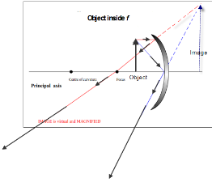
Use a ray diagram to show the formation of an image by a convex mirror. | 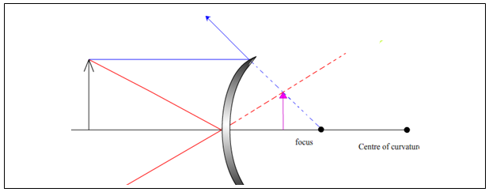
Describe the image that is formed in a concave mirror when an object is placed inside the focus. | The image is virtual, magnified and upright.
Describe the image that is formed in a concave mirror when an object is placed outside the focus. | The image is real and inverted.
Describe the image that is formed in a convex mirror. | The image is virtual, diminished and upright.
Give two uses for a concave mirror. | Torch, headlights, searchlight, dentist mirror, cosmetic mirror, solar furnace.
Give two uses for a convex mirror. | Door mirror of a car  In shops to deter shoplifters  At concealed entrances to give a view of oncoming traffic
Give one difference between a real image and a virtual image. | Real image can be formed on a screen; virtual image cannot.  In real image the light rays meet; in virtual image they do not.  A real image is always inverted/ a virtual is erect,  a real image is in front / a virtual image is behind.
Concave mirrors, rather than convex mirrors, are used by dentists to examine teeth. Explain why. | They give a magnified image
Why is a convex mirror used, instead of a plane mirror, as a door mirror on a car? | A convex mirror offers a wider field of view

Parallax Error
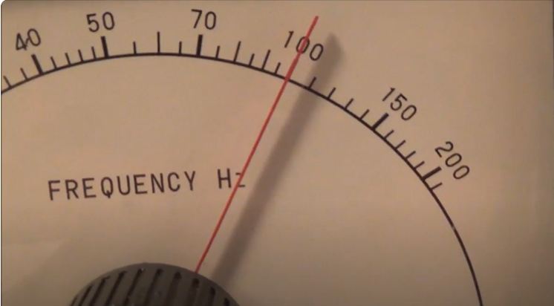
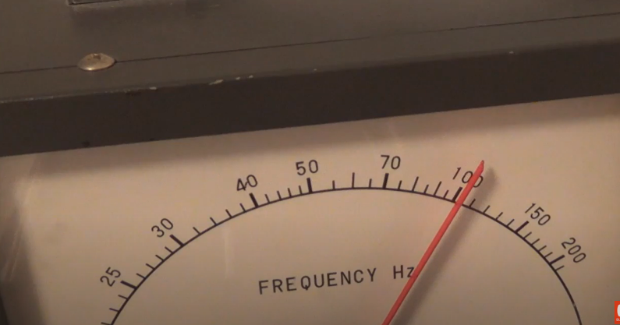

These are two photos of the same instrument. The position of the pointer hasn’t changed but the position of the camera has and therefore the angle between the camera and as a result it is unclear whether the pointer is over the 100 mark or is halfway between 100 and 110. The issue arises if you look at the pointer from anywhere other than directly in front (or directly overhead if the scale is horizontal) and the associated error is known as parallax error.
A parallax error is the apparent shift in an object's position as it is viewed from different angles.

To avoid parallax error we should ensure that the viewing angle is perpendicular to the scale at the point where we are taking the reading.

This effect is probably most noticeable if you are in the passenger seat of a car and you look across at the speedometer. You will read the speed as being considerably greater than it actually is. Remember to explain this to your dad next time you’re driving and he is in the passenger seat having a mild heart attack.

Still 1 | Still 2 | Still 3
 |  | 
The stills above are taken from a video as filmed by a passenger in a second plane. If you watch the video in full it looks like the plane in these photos is actually going backwards.
Which photo is correct? See video clip here.

Exam questions Mirrors 2002 – 2023

Ordinary level
2017 Question 7
A ray of light can undergo both reflection and refraction.
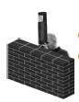
- What is meant by reflection of light?
- State the laws of reflection.

- The periscope, like the one in the diagram, is an application of the reflection of light that allows a person to see over objects.
Draw a diagram to show how a periscope works.
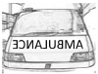
- The diagram shows the word AMBULANCE written so that a driver can read it correctly in a car mirror.
Explain why the driver can read the word correctly in the mirror.

2012 Question 12 (b)
- State the laws of reflection of light.
- How would you estimate the focal length of a concave mirror?
- The diagram shows an object O in front of a concave mirror, whose focus is at F.
Copy and complete the diagram to show the formation of the image of the object O.
- Give one use for a concave mirror.

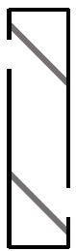
2021 Question 10
A periscope is used on a submarine. The periscope uses plane mirrors to allow a person on the submarine to see above the surface of the water.
- Describe how a periscope works.
Your answer should include a labelled diagram showing the path of a ray of light through the periscope.
- State the laws of reflection of light.
- Describe an experiment to demonstrate the laws of reflection.
- Light can also be reflected from spherical mirrors. Two types of spherical mirrors are concave mirrors and convex mirrors.

- Copy the ray diagram below into your answerbook and complete it to show how a real image is formed in a concave mirror.
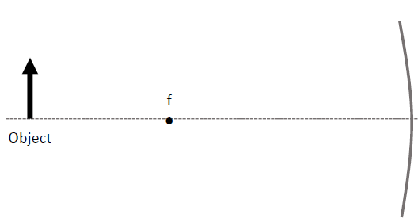
An object of height 2 cm is placed 17 cm in front of a concave mirror.
An image with a height of 3 cm is formed.
- Calculate the magnification.
- Calculate the image distance.
- State one use of a concave mirror.
- State one use of a convex mirror.

2004 Question 12 (b)
- A concave mirror can produce a real or a virtual image, depending on the position of the object.
- Give one difference between a real image and a virtual image.
- Use a ray diagram to show the formation of a real image by a concave mirror.
- A concave mirror has a focal length of 20 cm. An object is placed 30 cm in front of the mirror.
How far from the mirror will the image be formed?
- Give two uses for a concave mirror.

2022 Question 9
When light is reflected from a concave mirror, the image produced may be real or virtual.
- What is meant by reflection?
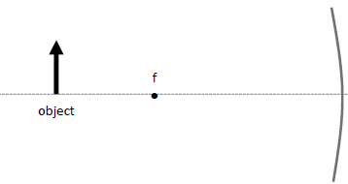
- In your answerbook, copy and complete the ray diagram below to show how a magnified image is formed in a concave mirror.

- The image formed is real. Explain what is meant by a real image.

- The object is 20 cm in front of the concave mirror. The mirror has a focal length of 12 cm.
Calculate the position of the real image formed.
- The object has a height of 4 cm. Calculate the height of the image.
- State one use for a concave mirror.

Light is also reflected by convex mirrors.
- Sketch a convex mirror. Indicate which side of the mirror reflects light.
- The image produced in a convex mirror is always virtual. Explain what is meant by a virtual image.
- State one use for a convex mirror.

Higher level
2018 Question 11
In 1845 the 3rd Earl of Rosse built the 15‐metre long Leviathan optical telescope It was a reflecting telescope that contained a concave mirror with a focal length of 16 m.
  - Calculate the position of the image of a person standing 75 cm from the Leviathan mirror.
  - Where, with respect to the concave mirror, will an image of the moon be formed?
Justify your answer. (radius of the Earth = 6400 km)
  - A concave mirror can also be used as a microscope to magnify images. Draw a ray diagram to show the formation of an upright, magnified image in a concave mirror.
2019 Question 11
A magnifying glass is a basic microscope.
Draw a ray diagram to show the formation of an upright image in a magnifying glass.

2017 Question 12 (c)
It has been recently suggested that the 17th century Dutch artist Rembrandt used a concave mirror to help him etch self-portraits by projecting an inverted image of himself onto a copper sheet.
- Draw a ray diagram to illustrate how Rembrandt used a concave mirror in this way.
Rembrandt used a concave mirror of focal length 60 cm so that the image on the copper sheet was only half the size of the object.
- Calculate the distance from the sheet to the mirror.
- Calculate the distance from the object to the mirror.
- A concave mirror can also be used to produce an upright image.
Explain why this image was not of use to Rembrandt.

2014 Question 12 (b)
- What is reflection?
- Spherical mirrors can be either convex or concave.
Draw a ray diagram to show the formation of an image in a convex mirror.
- A person looks at her image in a shiny spherical decoration when her face is 30 cm from the surface of the decoration. The diameter of the decoration is 20 cm.
Find the position of the image.
- Concave mirrors, rather than convex mirrors, are used by dentists to examine teeth. Explain why.

The science of learning quiz: Part 3

  - What is meant by the term ‘illusions of competence’?

  - What is the Dunning-Kruger effect?

  - Recap:
Memory formation can be divided into three different stages. Name each stage and explain each term

  - How can we ‘encode’ information when we first encounter it?

Answers

  - What is meant by the term ‘illusions of competence’?
It is very common for a student to develop a false sense of mastery of the material which can in turn lead to over-confidence. This can happen when you are watching a teacher go through a problem on the board which seems to make sense, but then when you’re asked to repeat it yourself you quickly realise that you don’t actually understand it after all. It can also happen when you highlight or ‘look over’ material instead of using a more reliable study technique like ‘elaborative interrogation’ which we will come across later.
Alternative explanation:
The terms refers to a student thinking they know/understand a concept when they don’t. This is very common if the student has merely read the material or passively watched the teacher explain it in class (or maybe watched a video of somebody explaining the idea on YouTube. The only way to be sure that you know the material is to test yourself on it either by writing it down or ideally by explaining it so somebody else.
Overcoming Illusions of Competence, Dr. Elizabeth Bjork. 2 minute YouTube video
Back

  - What is the Dunning-Kruger effect?
This is the effect whereby the less we know about a subject, the less competent we are to judge whether we know it or not. In other words the very fact that we know very little about the subject is likely to make us overly confident. Which isn’t ideal if we have a test on that subject the following day.

A well-known illustration of this is that something like 90% of the population’s drivers believe themselves to be above average drivers. Then the survey is carried out on just those who have picked up tickets for dangerous driving the percentage actually goes up rather than down.

Another example of this effect is when students use an existing marking scheme to judge how well they did with a specific question. The struggling students are the very ones most likely to overestimate the marks they would have got and this in turn leads to an illusion of competence which we looked at earlier.
1 minute explanation from John Cleese on YouTube
Slightly longer (5 minute) YouTube video
Back

  - Memory formation can be divided into three different stages. Name each stage and explain each term
Encoding the information into the brain: getting it into the brain’s short term memory.
Storing the information for future use in the brain’s long term memory.
Retrieving the information: getting it back out from the brain’s long term memory.

  - How can we ‘encode’ information when we first encounter it?
Your brain needs to concentrate on the material in some meaningful way. This is referred to as ‘interrogating the material’.
Have you ever walked out of your house and wondered if you locked the door only to go back to realise that you did? Why couldn’t you remember?
Because you weren’t thinking about what you were doing.
When something ‘goes in one ear and out the other’ it's usually because it didn’t have anything to stick to along the way.

Back to the physics . . .

3: REFRACTION

Something to think about
“Twinkle twinkle little star . . .”
Why do stars twinkle but not planets?

Student Notes
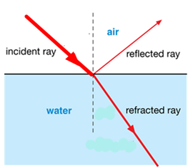
Refraction
Refraction is the bending of a wave as it passes from a medium of one refractive index to another medium of different refractive index.
Strictly speaking only some of the light passes through to the second medium; the rest of it gets reflected back. The reflected ray is known as the weak reflected ray. To make life simple we pretend that the reflected ray doesn’t exist. That is until the 2016 higher level paper when to absolutely everyone’s surprise it turned up in Question 5.

When light travels from a medium of lower refractive index to a medium of higher refractive index it is refracted towards the normal (and vice versa.)

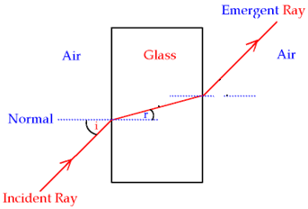

Laws of refraction of light
When light undergoes refraction we can say two things for definite about it. These are known as the laws of refraction:
- The incident ray, the normal and the refracted ray all lie on the same plane.
(not to be confused with the reflected ray, from the laws of reflection).
- The ratio of the sin of the angle of incidence to the sin of the angle of refraction is constant.
The second law of refraction is also known as Snell’s law.

The refractive index of a medium is the ratio of the sin of the angle of incidence to the sin of the angle of refraction when light travels from a vacuum into that medium.
This leads to the following definition:
In practice we consider air and a vacuum to be equivalent.

$$R.I.=\frac{sin i}{sin r}$$

The symbol for refractive index is ŋ.

2018 Question 5 [Ordinary level]  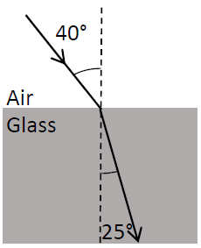  Calculate the refractive index of the glass block shown in the diagram. | Solution  $ŋ=\frac{\sin{i}}{\sin{r}}= \frac{\sin{40}}{\sin{25}}$ = 1.52

Note that if you see the phrase “the refractive index of glass is 1.5”, it implies that light is travelling from air into glass.
This is written as _{a}η_{g} = 1.5

If light is going in the other direction (from glass to air), the refractive index will be the inverse of 1.5.
i.e. if _{a}η_{g} = 1.5, then _{g}η_{a} = $\frac{1}{1.5}$
If _{a}η_{g} = 1.5, then _{g}η_{a} = $\frac{1}{1.5}$

Refractive index and colour

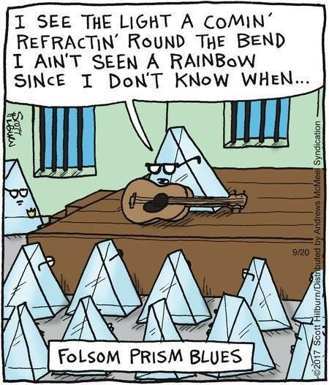
Refractive index also depends on the colour (or, as we’ll see later on, wavelength) of the light so the refractive index for blue light in glass is slightly different than the refractive index for red light in glass. This means that different colours will refract by different angles as they pass through a prism. White light is composed of all colours so if you shine white light through a prism (or a raindrop) each colour will refract by a different amount so the colours all separate – and that’s how you get a rainbow. Hence the cartoon (which admittedly will only make sense to Johnny Cash fans)

2022 Deferred examination Question 12 (b)  A ray of blue light is incident on a rectangular glass block. A ray of red light, incident at the same point on the glass block, takes a different path in the block. Explain why this is happens. | Solution  Each colour (or wavelength) has a different refractive index so red light refracts at a different angle to blue light.

Critical angle

The diagram shows a ray of light inside a glass block striking the glass/air interface.

Look at the glass block in the diagram.

When the angle of incidence (in the glass block) reaches a certain (critical) angle it results in the light no longer refracting outward but instead travelling along the surface.

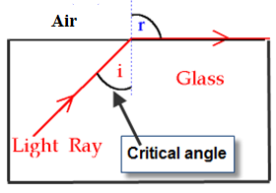
The angle of refraction is now 90⁰, and this leads to a definition of the critical angle:

The critical angle is the angle of incidence which
corresponds to an angle of refraction of 90⁰.

Relationship between critical angle and refractive index
$$R.I.of a medium=\frac{1}{sin C}$$

Maths questions on the critical angle take one of two forms; given the critical angle, find the refractive index and given the refractive index, find the critical angle. Examples of both are below but the second type is a little trickier and so is usually higher level.

Type 1: Given the critical angle, find the refractive index

2015 Question 5 [Ordinary level]  A glass block has a critical angle of 42°.  Calculate the refractive index of the glass used in the block. | $n=\frac{1}{\sin{c}}= \frac{1}{\sin{42}}$ = n = 1.49
2005 Question 7 [Ordinary Level]  A glass block has a critical angle of 41.8°. Calculate a value for the refractive index of the glass. | $n=\frac{1}{\sin{c}}= \frac{1}{\sin{41.8}}$ ⇒ n = 1.5

Type 2: Given the refractive index, find the critical angle

2010 Question 5 [Higher Level]  What is the critical angle of a sample of glass whose refractive index is 1.46? | n = 1.46, C = ?  $n=\frac{1}{\sin{C}}$ $\sin{C}=\frac{1}{n}$ $\sin{C}=\frac{1}{1.46}$  C = $\sin^{-1}{\frac{1}{1.46}}$ C = 43.2º
2015 Question 5 [Higher Level]  The refractive index of haematite is 3.2. What is its critical angle? | n = 3.2, C = ?  $n=\frac{1}{sin C}$ $\sin{C}=\frac{1}{n}$ $\sin{C}=\frac{1}{3.2}$  C = $\sin^{-1}{\frac{1}{3.2}}$ C = 18.21º
2007 Question 5 [Higher Level]  The refractive index of a liquid is 1.35, what is the critical angle of the liquid? | n = 1.35, C = ?  $n=\frac{1}{sin C}$ $\sin{C}=\frac{1}{n}$ $\sin{C}=\frac{1}{1.35}$  C = $\sin^{-1}{\frac{1}{1.35}}$ C = 47.8º

Total internal reflection

Remember our diagram for the critical angle?

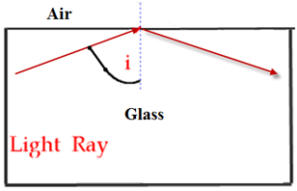
Now if we increase the angle of incidence beyond the critical angle, the light ray won’t actually leave the block at all, but will ‘reflect’ back as if it were striking the surface of a mirror.
We say that the light is now ‘totally internally reflected’.
Total internal reflection occurs when the angle of incidence is greater than the critical angle and light is reflected back into the denser medium.

2016 Question 5 [Higher level]  The diagram shows a light ray incident on the interface between glass and air.  Sketch (i) the refracted ray, (ii) the weak reflected ray. The critical angle of the glass is 42°. | I was very surprised to see any reference to a weak reflected ray here – it’s not a concept that would normally be on a second level textbook (but it probably should be).  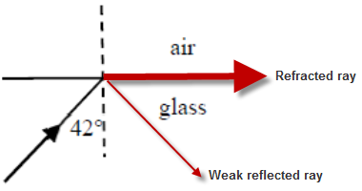  Secondly, the fact that there is light at the interface travelling in the fashion shown in the second diagram is something that you see in most textbooks but is a common misconception – so it’s just plain wrong to give this answer. The explanation is a wonderful story invoking probability and quantum physics but this is probably not the place or the time.  Bottom line is that we have to play the game - so see diagram for answer:

Using a prism to turn a ray of light through (i) 90⁰ (ii) 180⁰

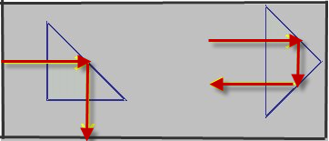

Applications of total internal reflection
- Reflective road signs
- Endoscopes
- Periscopes
- Optical fibres

For belayers of all levels who are tired of having a sore neck, indoors or on the cliff. From Decathlon €27.00 | 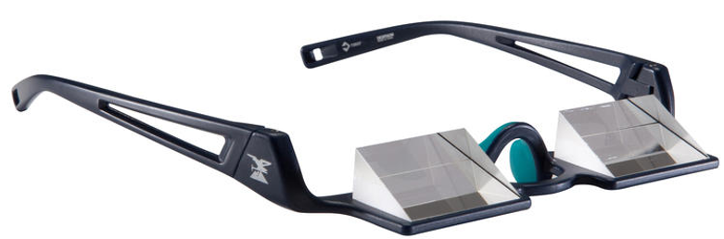
USB endoscope inspection tube camera  Ebay €24.00 | 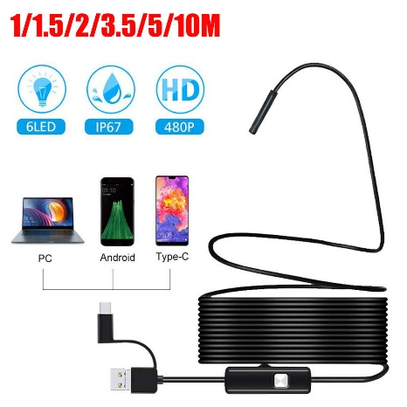
Periscope | 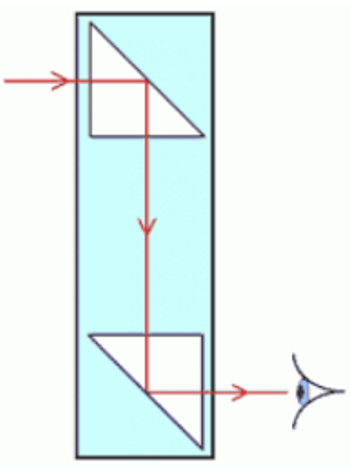
Cat’s eyes road reflectors | 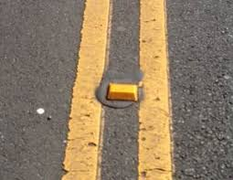  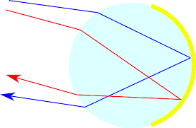

Optical fibres
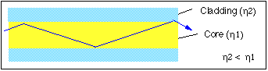

How light is transmitted in an optical fibre
- An optical fibre consists of a glass pipe coated with a second material of lower refractive index.
- Light enters one end of the fibre and strikes the boundary between the two materials at an angle greater than the critical angle, resulting in total internal reflection at the interface.
- This reflected light now strikes the interface on the opposite wall and gets totally reflected again.
- This process continues all along the glass pipe until the light emerges at the far end.
Note:
- You must include the terms in bold above.
- If the second cladding material had a refractive index greater than that of the central core total internal reflection would not occur and the light would simply escape out.
- The outer cladding also acts as a protective layer against scratches etc.
- The word "fibre" comes from the fact that these cables are incredibly thin, about the size of a hair.

Applications
- Broadband
- Endoscopes (note that ‘medicine’ is too vague).

Advantages of optical fibres over copper conductors
Cheaper raw material / occupy less space / flexible for inaccessible places/ do not corrode /less interference

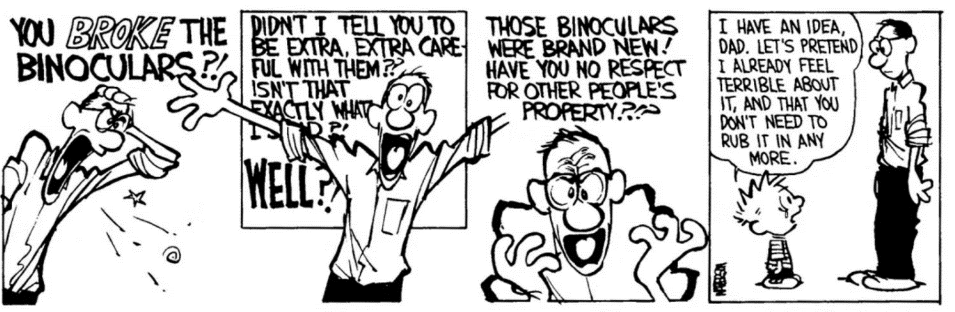
Binoculars also use total internal reflection. As parents we often speak to our children in a manner that we would never use to speak to a partner or colleague, and we do it in part because we know that we can get away with it. Which makes it a very cowardly act. Of course I still do it, just (hopefully) not as much as I used to, and I usually feel guilty afterwards. I think we all know that teachers are guilty of it from time to time also.

Refractive index in terms of the speed of light in different media

Light travels at different speeds in different media. The relationship between these speeds leads to another formula for the refractive index of a medium:
R.I$.=\frac{C_{air}}{C_{medium}}$
$$R.I. of medium=\frac{speed of light in air}{speed of light in medium}$$

Or

Note that the speed of light is 300000000 metres per second! That’s a rather unwieldy number so to make life easier (sort of) we use scientific notation.
The speed of light in scientific notation is written as 3 × 10⁸ m s⁻¹. That’s 300 million metres per second or 300 000 km per second.

Before trying the exam questions below we will first revise scientific notation.
If you need further assistance then go to the relevant section in your Junior Cert maths book.

You will also need to be comfortable using scientific notation on your calculator.

By the way, nothing can go faster than the speed of light.

A crash course on scientific notation

Scientific notation allows us to easily represent very big or very small numbers.

Some examples:
The speed of light is approximately three hundred million metres per second.
We write this number mathematically as follows:
300 000 000 m s⁻¹ or, using scientific notation, 3 × 10⁸ m s⁻¹

It takes approximately 200 000 (2 × 10⁵) joules of heat to boil a kettle and 50 000 000 (5 × 10⁷) joules to heat a bath of water.

We can also use prefixes as shorthand for some scientific notation:

Prefix | Symbol | Factor
milli- | m | × 10⁻³
micro- | μ | × 10⁻⁶
nano- | n | × 10⁻⁹
pico- | p | × 10⁻¹²
kilo- | k | × 10³
mega- | M | × 10⁶
giga- | G | × 10⁹
tera- | T | × 10¹²

You will also find the information above on page 45 of the Formula & Tables book

Examples
1 thousandth | .001 | 1 × 10⁻³
1 millionth | .000 001 | 1 × 10⁻⁶
1 billionth | .000 000 001 | 1 × 10⁻⁹
1 thousand | 1000 | 1 × 10³
1 million | 1000 000 | 1 × 10⁶
1 billion | 1000 000 000 | 1 × 10⁹

For example 1 million joules = 1 × 10⁶ J = 1 megajoule = 1 MJ
.0052 metres = 5.2 × 10⁻³ m = 5.2 millimetres = 5.2 mm

Try to identify the name or the term using the clues below

1 x 10¹² firmas

2 x 10¹² bulls

1 x 10⁹ lows

2 x 10⁶ phones

1 x 10³ manjaros

1 x 10³ whales

2 x 10³ mockingbirds

1 x 10 ⁻³ pedes

1 x 10⁻³ nnium

1 x 10⁻³ taries

2 x 10⁻⁶ scopes

3 x 10⁻⁶ phones

1 x 10⁻¹² boos

Answers
- 1 terra firma
- 1 terabull
- 1 gigalow
- 2 megaphones
- 1 kilomanjaro
- 1 kilowhale
- 2 kilomockingbird
- 1 millipede
- 1 millennium
- 1 military
- 2 microscopes
- 3 microphones
- 1 picaboo

Question: What is the unit for the level of beauty required to launch a single ship?
Answer: The millihelen

Meanwhile, back at the ranch . . .

2009 Question 12 (c) [Higher Level]  An optical fibre has a refractive index of 1.55.  What is the speed of the light as it passes through the fibre? | Refractive index = $\frac{speed of light in air}{speed of light in medium}$  1.55 = $\frac{3×{10}^{8}}{speed of light in medium}$  Speed of light in medium = 1.94 × 10⁸ m s⁻¹
2018 Question 5 [Higher Level]  The refractive index of a material is 2.4.  Calculate the speed of light in this material. | Refractive index = $\frac{speed of light in air}{speed of light in medium}$  2.4 = $\frac{3×{10}^{8}}{speed of light in medium}$  Speed of light in medium = 1.25 × 10⁸ m s⁻¹
2013 Question 5 [Higher Level]  If a diamond has a refractive index of 2.42, what is the speed of light in the diamond? | $2.42= \frac{speed of light in air}{speed of light in diamond}$  $speed of light in diamond= \frac{3{ × 10}^{8}}{2.42}$  Speed of light in diamond = 1.24 × 10⁸ m s⁻¹

2017 Question 11 [Higher Level]
An optical cable carries a signal from London to New York in 29 milliseconds. The distance between both cities is 5500 km.
Calculate the refractive index of the glass used in the cable.
Solution
One millisecond is one thousandth of a second = 0.001 seconds = 1 × 10⁻³ seconds
One kilometre is one thousand metres = 1000 m = 1 × 10³ m
Speed of light in air = 3 × 10⁸ m s⁻¹ | Speed of light in glass = $\frac{distance}{time}= \frac{5500 × {10}^{3}}{29 × {10}^{-3}}$ = 1.9 × 10⁸ m s⁻¹
$n= \frac{c_{air}}{c_{glass}}= \frac{3×{10}^{8}}{1.9×{10}^{8}}$ = 1.58

Refractive index in terms of real depth and apparent depth

Refraction explains why a swimming pool is deeper than it actually appears to be.

2019 Question 12 (c)
A diver is 12 m below the surface in a pool of water.
Use a labelled diagram to explain why the diver does not appear to be at a depth of 12 m when viewed by an observer outside the pool.
Solution
The object at the bottom of the pool represents the diver (bear with me here).

- We consider two rays of light coming from the object and moving towards the surface of the water.
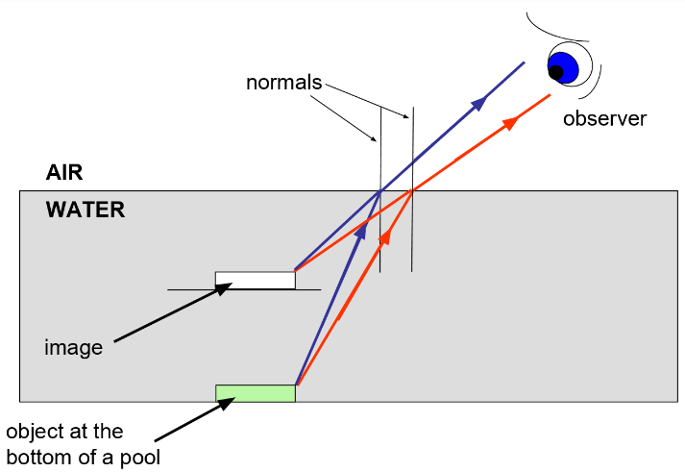
- As each ray of light leaves the surface of the water it refracts away from the normal.
- Both rays continue to diverge in the air but now the direction of each is different to when they were in water.
- Our brain follows its normal rule for determining where the object should be (back where the lines would ‘normally’ converge) with the result that the image seems to be higher up in the water than it actually is.

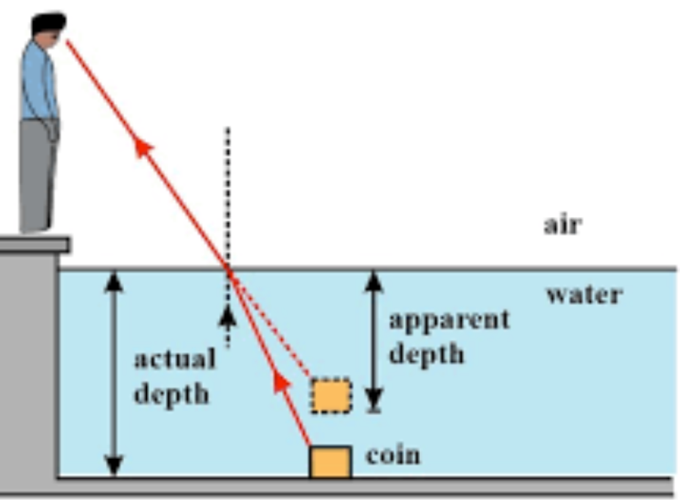

Real depth and apparent depth are related to refractive index as follows:

$$R.I.of a medium=\frac{Real depth}{Apparent depth}$$

Example  A diver is 12 m below the surface in a pool of water.  The refractive index of water is 1.33.  What is the apparent depth of the diver? | Solution  $n=\frac{Real depth}{Apparent depth}$  $1.33=\frac{12}{Apparent depth}$  $Apparent depth=\frac{12}{1.33}=9.02 m$

Neither of the formulae (relating refractive index to speeds or to real and apparent depth) above are in the Formula & Tables book
Revision question

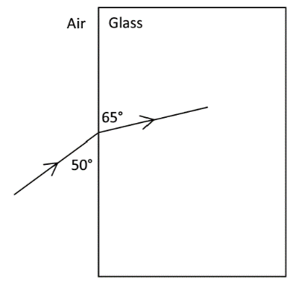
2022 Deferred Physics exam Higher Level 14 (b)
A ray of light is incident on a rectangular glass block, as shown in the diagram.

- Calculate the refractive index of the glass for the light.
- Calculate the speed of this light in the glass.

- A ray of red light, incident at the same point on the glass block, takes a different path in the block. Explain why this is happens.

Calculate the refractive index of the glass for the light.
The diagram is likely to cause confusion. The angle of incidence and the angle of refraction are all relative to the normal, so in this case you need to draw a normal at the air/glass interface and then note that the angle of incidence = 40° and the angle of refraction is 25°.
$n=\frac{\sin{i}}{\sin{r}}=\frac{\sin{40}}{\sin{25}}$ = 1.52

Calculate the speed of this light in the glass.
Refractive index = $\frac{speed of light in air}{speed of light in glass}$ 1.52 = $\frac{3×{10}^{8}}{speed of light in medium}$

Speed of light in medium = 1.97 × 10⁸ m s⁻¹

Explain why a ray of red light takes a different path than a ray of blue light.

The refractive index of glass for blue light is slightly different than the refractive index of glass for red lights, so red light refracts (bends) at a different angle to blue light.

Summary of formula

$R.I.=\frac{sin i}{sin r}$ $R.I.=\frac{Speed of light in air}{Speed of light in medium}$ $R.I.=\frac{1}{sin C}$

$$R.I.=\frac{Real Depth}{Apparent Depth}$$

If _{a}η_{g} = 1.5, then _{g}η_{a} = $\frac{1}{1.5}$

And remember boys and girls . . .
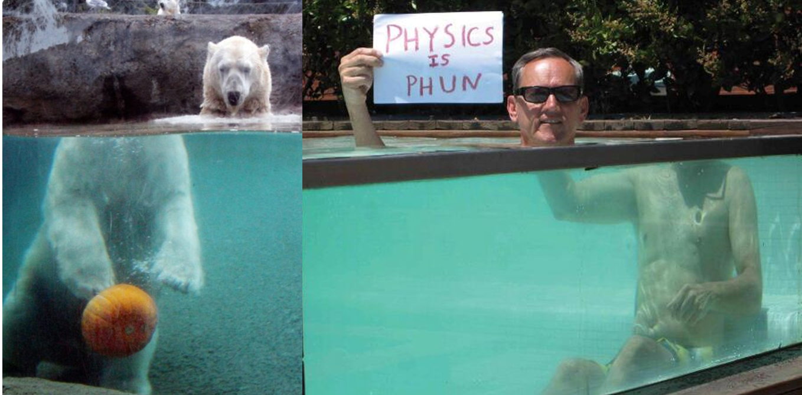

VERIFICATION OF SNELL’S LAW OF REFRACTION
and
TO MEASURE THE REFRACTIVE INDEX OF A GLASS BLOCK
APPARATUS: Glass block, ray-box, protractor, page

DIAGRAM: Add in a ray-box

PROCEDURE
- Place a glass block on the page and mark its outline.

- Shine a ray of light from the ray-box into the glass block.

- Mark two dots on the incident ray and exit ray and draw the outline of the block.

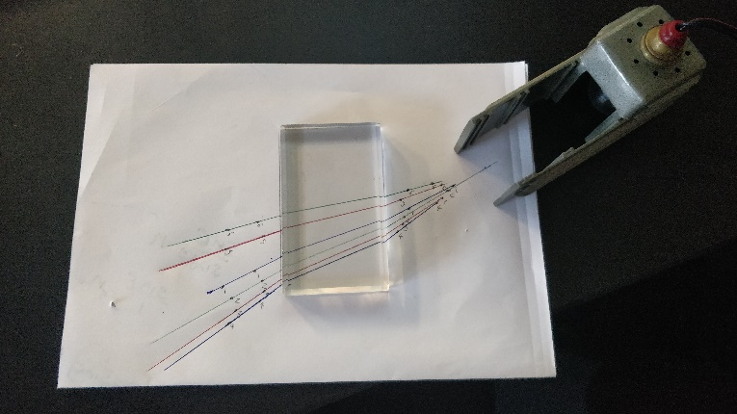
- Remove the block and complete all lines including the normal, as indicated on the diagram.

- Measure the angle of incidence i and angle of refraction r using the protractor.

- Repeat for different values of i.

- Draw up a table as shown.

- Plot a graph of sin i against sin r.

- The slope of the line gives a value for the refractive index of glass – see graph for calculations

Conclusion
We obtained a straight line through the origin thus verifying Snell’s law of refraction, i.e. sin i ∝ sin r.

RESULTS
i (degrees)
r (degrees
sin i
sin r

SOURCES OF ERROR / PRECAUTIONS
- Using small angles of incidence will result in large percentage errors.
- Place two dots far apart on the incident and refracted light beams to accurately locate the beams

Tip when carrying out the experiment
Start with a small angle of incidence and measure the corresponding angle of refraction.
Now increase this angle at roughly regular intervals each time to ensure a wide range of values (rather than simply taking angles at random each time).

Graph of sin i against sin r
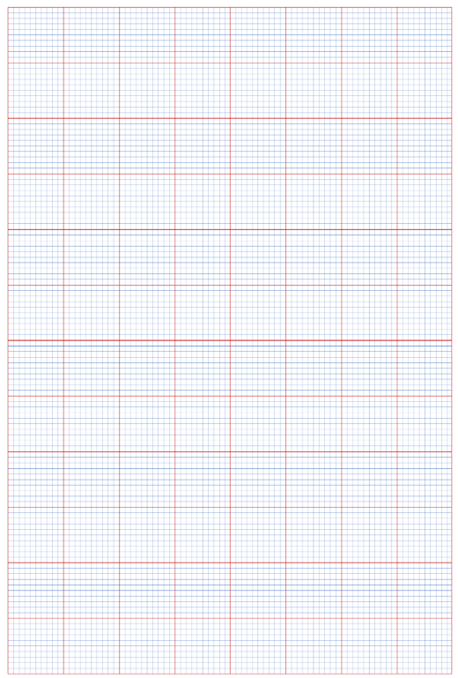

Theory questions
Draw a labelled diagram of the apparatus that could be used in this experiment.  Indicate on the diagram the angles i and r. | Diagram to show:  Glass block  Incident ray (from ray box), normal and refracted ray  Also include a protractor and raybox.
What measurements were taken during the experiment? | Angle of incidence and angle of refraction
Describe how the student found the path of the ray of light passing through the glass block. | Mark the points where the incident and exit rays touch the block.  Remove the block then join the points.
Describe, with reference to the diagram, how the student found the angle of refraction. | By measuring the angle between the normal and the refracted ray using a protractor.
Draw a suitable graph to illustrate the relationship between the angle of incidence and the angle of refraction. | Sin i on vertical axis, sin r on horizontal axis.  Correct sin i and sin r values for six points  Label axes correctly on graph paper  Plot points correctly  Straight line showing good distribution
Use your graph to find the refractive index of the material. | The slope of the graph corresponds to the refractive index of the material.
Explain how your graph verifies Snell’s law. | Straight line through the origin shows that sin i is proportional to sin r
The student did not record any values of i below 20°, why not? | There would be a greater percentage error associated with measuring smaller angles.
What would be observed if the incident ray was perpendicular to the block? | The light ray would go straight through (would not be refracted).
Using a graph to calculate a value for the refractive index is a more accurate method than calculating the refractive index for each pair of angles and then finding the mean. Give a reason for this. | Any errors can be more easily identified on a graph than in a table of data as the associated point will be well off the line so can be ignored.
Why was the experiment repeated? | To get a more accurate result
Using a graph to calculate a value for the refractive index is a more accurate method than calculating the refractive index for each pair of angles and then finding the mean.  Give a reason for this. | Using a graph increases the chances of identifying an outlier which can then be ignored.

Related exam questions

HL: 2018, 2014, 2010, 2005 OL: 2016, 2013, 2012, 2008, 2006

- [2014]
In an experiment to measure the refractive index of a substance, a student used a rectangular block of the substance to measure the angle of incidence i and the corresponding angle of refraction r for a ray of light as it passed from air into the substance. The student repeated the procedure for a series of different values of the angle of incidence and recorded the following data:
2014
i/degrees | 20 | 30 | 40 | 50 | 60 | 70 | 80
r/degrees | 13 | 20 | 27 | 23 | 36 | 40 | 43

- One of the recorded angles of refraction is inconsistent with the others. Which one?
- Describe, with the aid of a labelled diagram, how the student found the angle of refraction.
- Calculate a value for the refractive index of the substance by drawing a suitable graph based on the recorded data.
- Using a graph to calculate a value for the refractive index is a more accurate method than calculating the refractive index for each pair of angles and then finding the mean.
Give a reason for this.

- [2005]
In an experiment to verify Snell’s law, a student measured the angle of incidence i and the angle of refraction r for a ray of light entering a substance. This was repeated for different values of the angle of incidence. The following data was recorded.
2005
i/degrees | 20 | 30 | 40 | 50 | 60 | 70
r/degrees | 14 | 19 | 26 | 30 | 36 | 40

- Describe, with the aid of a diagram, how the student obtained the angle of refraction.
- Draw a suitable graph on graph paper and explain how your graph verifies Snell’s law.
- From your graph, calculate the refractive index of the substance.
- The smallest angle of incidence chosen was 20⁰.
Why would smaller values lead to a less accurate result?

Solutions

2014
i/degrees | 20 | 30 | 40 | 50 | 60 | 70 | 80
r/degrees | 13 | 20 | 27 | 23 | 36 | 40 | 43
Sin i | 0.34 | 0.50 | 0.64 | 0.77 | 0.87 | 0.94 | 0.98
Sin r | 0.23 | 0.34 | 0.45 | 0.39 | 0.59 | 0.64 | 0.68
slope = n ≈ 1.44

2005
i/degrees | 20 | 30 | 40 | 50 | 60 | 70
r/degrees | 14 | 19 | 26 | 30 | 36 | 40
sin i | 0.34 | 0.50 | 0.64 | 0.77 | 0.87 | 0.94
sin r | 0.24 | 0.33 | 0.44 | 0.50 | 0.59 | 0.64
slope = n ≈ 1.49

SLOP

What is meant by refraction of light? | The bending of light as it passes from one medium to another medium of different refractive index.
State Snell’s law of refraction. | The ratio of the sine of the angle of incidence to the sine of the angle of refraction is a constant.
State the laws of refraction of light. | The incident ray, the refracted ray and the normal all lie in the same plane.  Sin i/ Sin r is a constant
What is meant by the refractive index of a material? | n = sin i/ sin r, where i is the angle of incidence and r is the angle of refraction.
Explain, with the aid of a diagram, how total internal reflection can occur.
Define the term total internal reflection. | Total internal reflection occurs when the angle of incidence in the denser of the two media is greater than the critical angle and light is reflected back into the denser medium.
When will total internal reflection occur? | When the angle of incidence is greater than the critical angle.
Define the term critical angle. | The critical angle corresponds to the angle of incidence in the denser of two media which causes the angle of refraction to be 90⁰.
Give two uses of total internal reflection. | Fibre optics, endoscopes, reflective road signs, telecommunications, binoculars, periscope.
Show how a prism can be used to rotate light through 180⁰.
Optical fibres
Draw a diagram to show the path of a ray of light travelling through an optical fibre.
Explain how a signal is transmitted along an optical fibre. | The angle of incidence greater than critical angle  Total internal reflection occurs  This is repeated all along the fibre
How is the escape of light from the sides of an optical fibre prevented? | Total internal reflection occurs due to an outer cladding of lower refractive index.
An optical fibre has an outer less dense layer of glass. What is the role of this layer of glass? | Total internal reflection will only occur if the outer medium is of lower density.  It also prevents damage to the surface of the core.
Give one use for optical fibres. | Endoscope, telecommunications, binoculars.
Give two reasons why the telecommunications industry uses optical fibres instead of copper conductors to transmit signals. | Less interference, boosted less often, cheaper raw material, occupy less space, more information carried in the same space, flexible for inaccessible places, do not corrode, etc.
Name a material that is used in the manufacture of optical fibres. | Glass / plastic / sand / silicon

Exam questions Refraction 2002 – 2023

Ordinary level
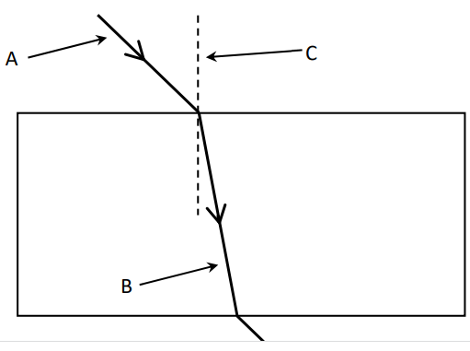
2023 Question 8
The diagram shows how a ray of light travels through a rectangular glass block.
- What is meant by refraction of light?
- Name A, B and C.
- Copy the diagram into your answerbook and label the angle of incidence i and the angle of refraction r.
- The refractive index of the glass block is 1.5. Calculate the angle of refraction when the angle of incidence is 35°.

2014 Question 8
A ray of light can undergo both reflection and refraction.
- Explain what is meant by reflection of light.
- State the laws of reflection of light.
- Give an application of reflection of light.
- Describe an experiment to demonstrate one of the laws of reflection of light.
- The diagram shows a ray of light travelling from glass to air.
The ray of light undergoes refraction at B.
Explain what is meant by refraction of light.
- What special name is given to the angle of incidence, i, when the effect shown in the diagram occurs?
- In the diagram the value of the angle i is 38⁰.
Calculate the value of the refractive index of the glass.
- Draw a diagram to show what happens to the ray of light when the angle of incidence is increased to 40⁰.

2005 Question 7
- Reflection and refraction can both occur to rays of light.
What is meant by the reflection of light?
- State the laws of reflection of light.
- Describe an experiment to demonstrate one of the laws of reflection of light.
- The diagram shows a ray of light travelling from glass to air.
At B the ray of light undergoes refraction.
Explain what is meant by refraction.
- What special name is given to the angle of incidence i, when the effect shown in the diagram occurs?
- In the diagram the value of the angle i is 41.8⁰.
Calculate a value for the refractive index of the glass.
- Draw a diagram to show what happens to the ray of light when the angle of incidence i is increased to 45⁰.
- Give one application of the effect shown in the diagram you have drawn.

2003 Question 7 [Ordinary Level]
- State the laws of refraction of light.
- Explain, with the aid of a labelled diagram, (i) total internal reflection, (ii) critical angle.
- The diagram shows a 45º prism made of glass.
The critical angle for the glass is 42º.
- Calculate the refractive index of the glass.
- The diagram shows a ray of light entering the prism from air.
Copy the diagram and show the path of the ray through the prism and back into the air.
- Explain why the ray follows the path that you have shown.
- Give two uses of total internal reflection.

Higher level
These questions are all surprisingly difficult – even for higher level, so feel free to have a go but I usually don’t cover them until we’re revising the topic in Sixth Year.
2022 Deferred examination Question 12 (b)
- State Snell’s law of refraction.

A ray of blue light is incident on a rectangular glass block, as shown in the diagram.
- Calculate the refractive index of the glass for the light.
- Calculate the speed of this light in the glass.
- A ray of red light, incident at the same point on the glass block, takes a different path in the block. Explain why this is happens.

2012 Question 12 (b)
The diagram shows a ray of light as it leaves a rectangular block of glass. As the ray of light leaves the block of glass, it makes an angle θ with the inside surface of the glass block and an angle of 30º when it is in the air, as shown.
- If the refractive index of the glass is 1.5, calculate the value of θ.
- What would be the value of the angle θ so that the ray of light emerges parallel to the side of the glass block?
- Calculate the speed of light as it passes through the glass.

2019 Question 12 (c)
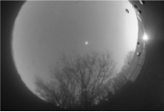
As light passes from water into air the critical angle may be exceeded and total internal reflection may occur.
- Explain the underlined terms.
- A diver is 12 m below the surface in a pool of water.
When he looks up he can see a circular window of light on the surface of the water.
Calculate the area of this disc of light.
- Use a labelled diagram to explain why the diver does not appear to be at a depth of 12 m when viewed by an observer outside the pool. (refractive index of water = 1.33)

2011 Question 12 (b)
- State the laws of refraction of light.

- A lamp is located centrally at the bottom of a large swimming pool, 1.8 m deep.
Draw a ray diagram to show where the lamp appears to be, as seen by an observer standing at the edge of the pool.
- At night, when the lamp is switched on, a disc of light is seen at the surface of the swimming pool. Explain why the area of water surrounding the disc of light appears dark.
- Calculate the area of the illuminated disc of water. (refractive index of water = 1.33)

Exam questions Optical fibres 2002 – 2023

Ordinary level
2017 Question 7 last part
Total internal reflection of light occurs in optical fibres which are used to transmit information.
- Draw a labelled diagram to show how total internal reflection occurs.
- Draw a labelled diagram to show how an optical fibre transmits light along its length.
- An optical fibre cable has a refractive index of 1.5.
Calculate the angle at which total internal reflection occurs.

2023 Question 14 (b)
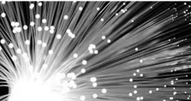
Light travels through an optical fibre using total internal reflection.
- Sketch the path of a ray of light through an optical fibre.
- Describe a laboratory experiment to demonstrate total internal reflection.
- The critical angle of the glass in an optical fibre is 43.6°.
Calculate n, the refractive index of the glass.
- State one use of an optical fibre.

2004 Question 11
Read the following passage and answer the accompanying questions.
Optical fibres are made of very transparent glass or plastic. The fibres contain at least two layers. Guiding light in an optical fibre depends on how light travels through different media. Light waves are bent, or refracted, as they pass between materials of different refractive index. The amount of bending depends on the refractive index and the angle at which light strikes the surface.
Sometimes light cannot leave the material of higher refractive index. If it strikes the surface at a large enough angle, it is reflected back into the material. The critical angle, for what is called total internal reflection, depends on the difference in refractive indexes. An optical fibre guides light by using total internal reflection.
(Adapted from New Scientist, 13 October 1990)
(a) Draw a diagram to show how a ray of light is transmitted through an optical fibre.
(b) How is the escape of light from the sides of an optical fibre prevented?
(c) Name a material that is used in the manufacture of optical fibres.
(d) What is the bending of light as it moves from one medium to another called?
(e) What is meant by the refractive index of a material?
(f) Define the critical angle.
(g) When will total internal reflection occur?
(h) Give one use for optical fibres.

2011 Question 7
Light rays can undergo reflection and refraction. Both of these can occur when light is travelling from a denser medium, such as glass, to a less dense medium, such as air.

- Explain the underlined terms.
- Give a practical application of the reflection of light.
- State the laws of reflection of light.
- Explain, with the aid of a diagram, how total internal reflection can occur.
- What is meant by the ‘critical angle’ in total internal reflection?
- The photo shows an optical fibre which is used for the transmission of data using light waves.
Draw a diagram to show how light waves travel along an optical fibre.
- Give two advantages of using optical fibres instead of copper wires when transmitting data.
- Optical fibres are also used in medicine. Give an example of their use in medicine.

Higher level
2004 Question 12 (b)
- Give two reasons why the telecommunications industry uses optical fibres instead of copper conductors to transmit signals.
- Explain how a signal is transmitted along an optical fibre.
- An optical fibre has an outer less dense layer of glass. What is the role of this layer of glass?
- An optical fibre is manufactured using glass of refractive index of 1.5.
Calculate the speed of light travelling through the optical fibre.
Speed of light in air = 3.0 × 10⁸ m s^{–1}

2009 Question 12 (c)
Information is transmitted over long distances using optical fibres in which a ray of light is guided along a fibre. Each fibre consists of a core of high quality glass with a refractive index of 1.55 and is coated with glass of a lower refractive index.
- Explain, with the aid of a labelled diagram, how a ray of light is guided along a fibre.
- Why is each fibre coated with glass of lower refractive index?
- What is the speed of the light as it passes through the fibre?

Light passing through optical fibres must travel through an enormous length of glass. Impurities in the glass reduce the power transmitted by half every 2 km.
The initial power being transmitted by the light is 10 W.
- What is the power being transmitted by the light after it has travelled 8 km through the fibre?
(speed of light in air = 3.0 × 10⁸ m s^{–1})

2017 Question 11
In the late 20th century, communication of signals using optical fibres became a reality, with several cables laid across the Atlantic. In 2015 the Hibernia Express optical cable was completed. It connects Cork and London to Halifax and New York and carries a signal from London to New York in 29 milliseconds.
- With the aid of a labelled diagram, explain how light is transmitted through optical fibres.
- Light travels a distance of 5500 km along the Hibernia Express between London and New York. Calculate the refractive index of the glass used in the cable.

The science of learning quiz: Part 4

- What is the significance of the phrase “Memory is the residue of thought” in relation to study skills?

- ‘Elaborative interrogation’ is an excellent (but not widely used) study technique. What is meant by this term?

- Finish this sentence as it relates to memory formation: “When recall is easy, learning is . . .

Answers

- What is the significance of the phrase “Memory is the residue of thought” in relation to study skills?
This follows on from the previous question. Long term memories are formed as the residue of thought. In other words, you need to be thinking about the material in order to remember it.
Were you ever sent to pick up just three items from the shop and end up only thinking of two? You didn’t write them down because you knew that you wouldn’t forget. Or come up with a new password that you know that you’re never going to forget, and one you really ‘want’ to remember, only to have forgotten it next time you go to log into that website?
You simply didn’t think about the items in any meaningful way so the information merely briefly passed through your consciousness without ever registering with it.
Here’s another way of putting it: “Learning happens when you have to think hard”.
We will look at examples of studying which require thinking (and are therefore effective) and examples which don’t (necessarily) require thinking and are therefore ineffective. Can you think of examples of each now?
3 minute YouTube video set as a college assignment (it just seems longer)

The Science of Thinking: 11 minute YouTube video from Veritasium

- ‘Elaborative interrogation’ is an excellent (but not widely used) study technique. What is meant by this term?
This follows on from the previous question.
Pretend that the knowledge is the subject of a detailed interrogation where you’re the detective looking to find out everything you can about it so that can embed it into existing knowledge (how does this ‘fact’ fit in with what you already know?). One way to do this is to arrange the ideas in a chapter in order of importance and show how they link together (perhaps in a mindmap format). This also ties in with the concept of ‘deep processing’ which we came across in the CrashCourse Psychology video on How we make memories which we watched at the very beginning.
One minute video from The Learning Scientists

- Finish this sentence as it relates to memory formation: “When recall is easy, learning is . . .
When recall is easy, learning is low.
We feel clever when we recall something instantly but in terms of getting our brain to store information we should feel the exact reverse. It’s as if your brain assumes that if it had to work hard to remember something then that ‘something’ must be important, so it stores it even more securely for the future.
This is why most effective learning techniques involve testing, because just staring at the information isn’t good enough: learning needs effortful recall. And it’s why going over material you covered a week or a month ago is so effective.

And now back to physics . . .

4: LENSES
Student notes
Two types of spherical lens are convex (which is also called ‘converging’ because it causes rays which are arrive parallel to the principle axis to converge) and concave (caves in as you look at it – also called ‘diverging’).

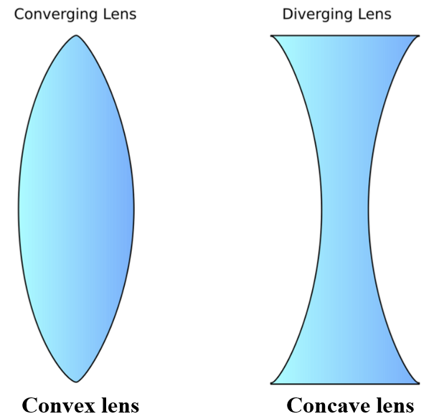

Why does a converging lens cause light to converge?

2015 Question 12 (b) [Higher Level]
When light passes through a lens, it is refracted at both faces of the lens.
Copy the diagram on the right into your answer book and complete the path of the light ray through the section of the lens. Include the normal at both faces.

Solution
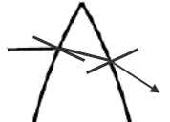
Look at the image on the right, where the ray of light is coming in from the left hand side.:
- At the first interface the light ray is travelling from a medium of low refractive index to a medium of higher refractive index and so bends towards the normal.
- The opposite happens at the second interface (light ray bends away from the normal). You should try this exercise for yourself, but this time work with the bottom half of the lens so see the direction of the emergent ray.
Now try it again, but this time use a diverging lens

Convex (converging) lenses - ray diagrams
We use simple rules to help us see what an image will look like when viewed through a convex lens.

Three rules (we only need to use two for any particular image formation):
- A ray of light which meets the lens after travelling parallel to principal axis will refract through the focus on the other side.
- A ray of light hitting the lens at the intersection of the principal axis and the lens will continue straight.
- A ray of light which meets the lens after passing through the focus will refract out parallel to the principal axis.

For each of the following label the focus, the object and the image.
Put arrows on all rays, and state whether the image is real or virtual, upright or inverted, magnified or diminished.
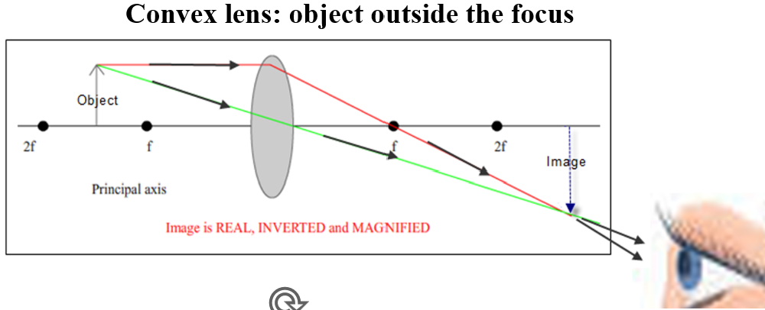

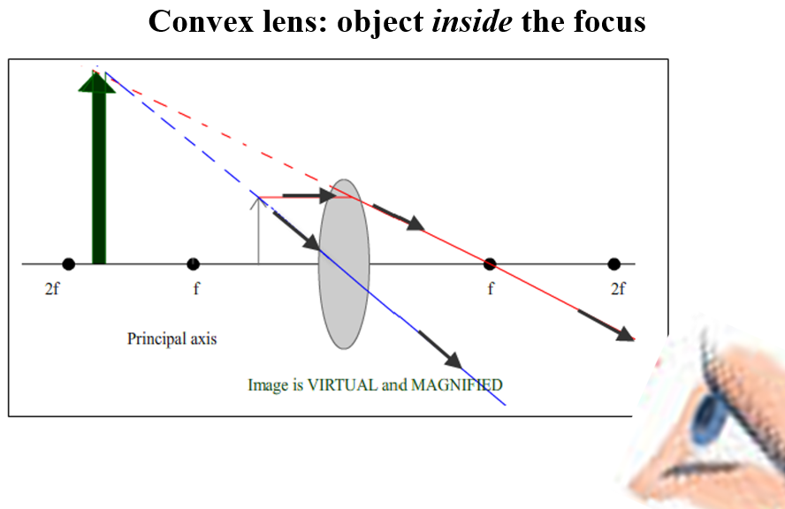

Notice that when the object is inside the focal point the light rays never intersect, but from the viewer’s perspective they appear to do so on the same side of the lens as the object (the viewer is to the right of the lens in the diagrams above).

Note
A real image is always on the other side of the lens (to the object) and is inverted.
A virtual image is always on the same side of the lens is upright.

Concave (diverging) lenses - ray diagrams
Here only one diagram is needed; the image is always diminished, upright and virtual.

Two Rules
- Draw a ray coming from the top of the object to the lens, parallel to principal axis and up as if coming from the focus.
- Draw a ray coming from the top of the object to centre of lens and continue straight through.

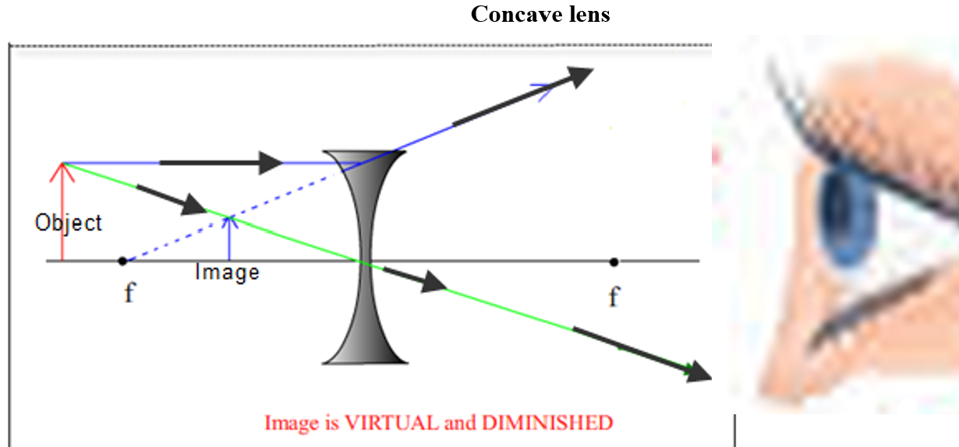

Notice that in this situation (similar to the convex lens when the object is inside the focus) the light rays never intersect, but from the viewer’s perspective they appear to do so at the same side of the lens as the object.
The image is therefore always virtual, regardless of where the object is placed.

Maths Problems

Relationship between focal length (f), object distance (u) and image distance (v)

Convention
For a convex lens f is positive
For a concave lens f is negative

If you are looking for v and it turns out to be positive, it means that the image is a real image.
If you are looking for v and it turns out to be negative, it means that the image is a virtual image.

This is referred to as the real is positive convention (Think ‘RIP’).

Remember that for a convex lens the image is only virtual if the object is inside the focus.
For a concave lens the image is always virtual.

Magnification

Similar to mirrors, magnification refers to the ratio of the height of the image to the height of the object.
$$M=\frac{image height}{object height}= \frac{v}{u}$$

The diagram below (which you don’t need to know) illustrates why the ratio between image height h_{i} and object height h_{o} is equal to the ratio between the image distance (v) and the object distance (u).

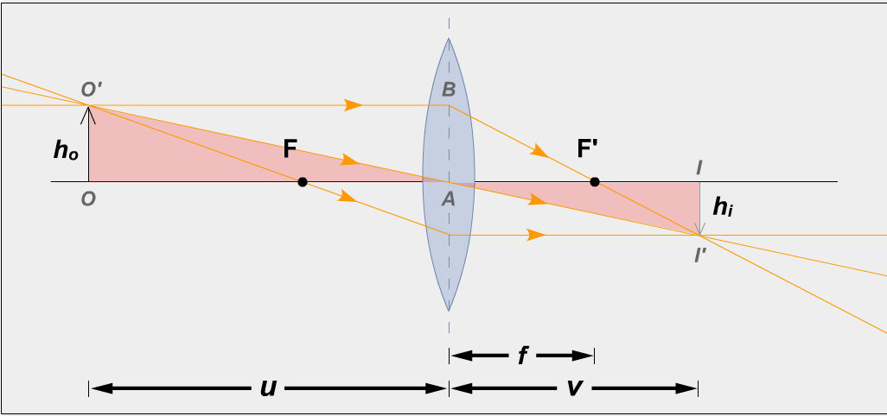

Related maths problems

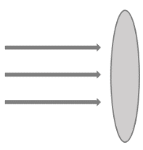
2020 Question 7 [Ordinary Level]
A converging lens has focal length 15 cm.
An object is placed 20 cm in front of the lens.
- Copy and complete the diagram below to show the paths of the rays of light after they strike the converging lens.
- A converging lens can be used to produce a magnified virtual image. Explain the underlined term.
- Calculate the image distance, v.
- Calculate the magnification, m.
- State one use of a lens.
Part (i) | 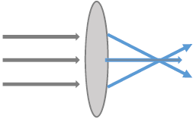
Part (ii) | A virtual image is formed by the apparent intersection of rays
Part (iii)  f = 15 cm  u = 20 cm  v = ? | $\frac{1}{f}=\frac{1}{u}+\frac{1}{v}$ $\frac{1}{v}=\frac{1}{f}-\frac{1}{u}$ $\frac{1}{v}=\frac{1}{15}-\frac{1}{20}$ $\frac{1}{v}=\frac{1}{60}$ v = 60 cm
Part (iv) | $m=\frac{v}{u}=\frac{60}{20}$ magnification = 3
Part (v) | magnifying glass, eye glasses /spectacles, camera, telescope etc
2006 Question 7 [Higher Level]
A converging lens has a focal length of 8 cm.
Determine the two positions that an object can be placed to produce an image that is four times the size of the object.
Solution
$M=\frac{v}{u}$ The image is 4 times the size of the object ⇒ M =4 $4=\frac{v}{u}$ ⇒ v=4u

$\frac{1}{f}=\frac{1}{u}+\frac{1}{v}$ ⇒ $\frac{1}{8}=\frac{1}{u}+\frac{1}{4u}$ ⇒ $\frac{1}{8}=\frac{\left(4\right)1+\left(1\right)1}{4u}$ ⇒ $\frac{1}{8}=\frac{5}{4u}$ ⇒ 4u = 40
⇒ u =10 cm

The second way an image can be formed is if the object is inside the focus.
This would result in a virtual image, and we represent this mathematically by making v negative.

$\frac{1}{f}=\frac{1}{u}+\frac{1}{v}$ ⇒ $\frac{1}{8}=\frac{1}{u}+\frac{1}{-4u}$ ⇒ $\frac{1}{8}=\frac{\left(4\right)1-\left(1\right)1}{4u}$ ⇒ $\frac{1}{8}=\frac{3}{4u}$ ⇒ 4u = 24

⇒ u =6 cm

Note that our value for u is less than the value for f, implying that the object is inside the focus, as we would expect.

The eye
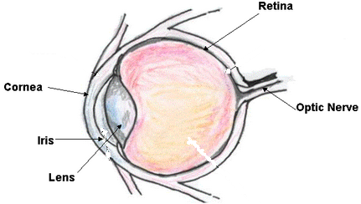
Cornea – together with the lens, form part of the focusing system.

Optic Nerve – carries the information in electrical form to the brain

Iris – acts like a shutter to control the amount of light entering the eye

Retina - light sensitive screen at the back of the eye

Different parts of the eye are composed of different tissues which in turn have different refractive indices.

Sunglasses which do not filter out UV light actually result in an elevated melanoma risk to the back of the eyes. Why?

Power of accommodation
The power of accommodation of the eye is its ability to focus a real image of an object onto the retina, whether the object is near to or far away. The eye does this by contracting and relaxing the ciliary muscles which support the lens which in turn changes the focal length (and the power) of the lens. Contracting the ciliary muscles pulls up on the lens causing it to get narrower. Relaxing the muscle causes the lens go get more round.

Now is the perfect time to tell me a joke about eyes; the cornea the better 😊

Fun demonstrations
The iris - ‘adjusting’ your eyes to the brightness
You know when somebody turns on the light in your bedroom in the morning it can actually be a little painful but after a few seconds the pain recedes? Conversely when we enter a dark room we are unable to see anything for the first few seconds but then slowly our eyes get ‘adjusted’ and we are able to discern faintly the objects around us. Why do our eyes react to light the way they do? The effect is even more impressive if you look into a colleague’s eyes as you suddenly go from complete darkness to brightness.
Explanation
Your iris acts like a pair of shutters which close together when too much light gets through and opens up when there is very little light in the background to enable more light to get through. If too much light gets through the receptors at the back of your eye get swamped with light and we interpret this as pain.
Optic Nerve / Blind Spot

Close one eye and look at the cross with the open eye – can you still see the black dot “out of the corner of your eye”?
Now slowly move your head towards the cross. Notice that at one particular distance the black dot disappears from the corner of your eye but then reappears as you move in closer. Why?
Explanation
This is because at that one specific position light from the black dot was falling on the opening to your optic nerve and there is no retina there so no light receptors. For this reason it is known as your blind spot.
Stereo Vision
Roll a piece of paper into a tube. Hold it with one hand, say, the left hand, and look at a distant object through it with your left eye, keeping your right eye closed. Now, bring your right palm in front of your right eye so as to touch the tube, and then, open your right eye as well. You will see the distant object clearly through a hole in your right palm! (Both hands should be about 15-20 centimetres from your eyes). It’s fantastic, isn’t it? How do you explain it?
Explanation
Your brain receives two separate images from your eyes and combines them. Usually the images are similar so you don’t notice any discrepancies.
Upside down glasses
The lens in our eye inverts the image of the object we’re looking at so that the image which forms on the back of our eye (the retina) is actually inverted. So why doesn’t the world look upside down?
What would happen if we wore a pair of glasses which made the image on the retina the right way up?
Explanation
The brain realises that the image on the retina is upside-down so takes this into account when ‘forming’ the final image. The upside-down glasses were first investigated by George Stratton in the 1890’s. Since the image that the retina of our eye sees is inverted, he wanted to explore the effect of presenting to the retina an upright image. He reported several experiments with a lens system that inverted images both vertically and horizontally. He initially wore the glasses over both eyes but found it too stressful, so he decided to wear a special reversing telescope over one eye and keep the other one covered.
In his first experiment, he wore the reversing telescope for twenty-one hours. However his world only occasionally looked normal so he ran another experiment where he wore it for eight days in a row. On the fourth day, things seemed to be upright rather than inverted. On the fifth day, he was able to walk around his house normally but he found that if he looked at objects very carefully they again seemed to be inverted. On the whole Stratton reported that his environment never really felt normal especially his body parts, although it was difficult to describe exactly how he felt. He also found that after removing the reversing lenses it took several hours for his vision to return to normal.
Defects of vision: short-sightedness and long-sightedness

Short sightedness (also known as myopia)
A short-sighted person can see nearby objects clearly but cannot bring distant objects into focus.
Short-sightedness is corrected with a concave (diverging) lens.

Long sightedness (also known as hypermetropia or hyperopia)
A long-sighted person can see distant objects clearly but cannot bring nearby objects into focus.
Long-sightedness is corrected with a convex (converging) lens.
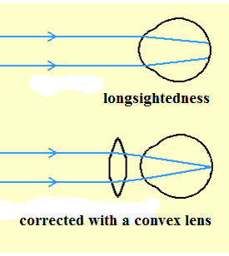
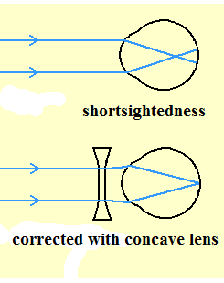

Power of a lens

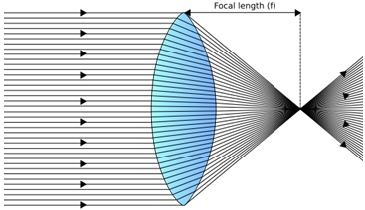
The power of a lens is simply the reciprocal of the focal length of the lens. We use it because it allows us to calculate the effect of having two lenses next to each other, where one is the lens in a short-sighted or long-sighted eye and the other is a corrective lens.
$$P= \frac{1}{f}$$
$$f= \frac{1}{P}$$

The unit of power is m⁻¹.

Two lenses in contact
If two lenses of power P₁ and P₂ are placed in contact, the power of the combination (P_{Total}) is given by
P_{Total} = P₁ + P₂

$$\frac{1}{f_{total}}=\frac{1}{f_{1}}+\frac{1}{f_{2}}$$

_{Or in terms of focal lengths:}

Remember to use the correct sign convention because a converging lens will have the opposite effect as a diverging lens.
Convention
The power of a converging (convex) lens is taken as positive (+) {because f is positive}.

The power of a diverging (concave) lens is taken as negative (-) {because f is negative}.

Power of two lenses – maths questions

2012 Question 5 [Higher level]  What is the focal length of a lens which has a power of -2 m⁻¹? | P = -2 m⁻¹  $P=\frac{1}{f}$ $f=\frac{1}{P}$ = $\frac{1}{-2}$ = – 0.50 m  Strictly speaking we didn’t need to include the ‘minus’ sign; it merely signifies that it is a diverging or concave lens.
2022 Question 6 [Higher level]  Calculate the effective focal length of two thin lenses in contact, one a converging lens of focal length 5 cm and the other a diverging lens of focal length 15 cm. | f₁ = 5 cm f₂ = –15 cm  $\frac{1}{f_{total}}=\frac{1}{f_{1}}+\frac{1}{f_{2}}$ $\frac{1}{f_{total}}=\frac{1}{5}+\frac{1}{-15}$  f_{total} = 7.5 cm
2004 Question 5 [Higher level]  Two converging lenses, each with a focal length of 10 cm, are placed in contact.  What is the power of the lens combination? | f = 10 cm = 0.1 m $P_{1=}\frac{1}{f}$ $P_{1=}\frac{1}{0.1}$ P₁ = 10 m⁻¹ P₂ = 10 m⁻¹  P_{Total} = P₁ + P₂ = 20 m⁻¹

Power of two lenses: The eye plus corrective lens

We have already seen that if two lenses of power P₁ and P₂ are placed in contact, the power of the combination (P_{Total}) is given by
P_{Total} = P₁ + P₂

This formula is used to determine the size and type of lens used to correct long--sightedness and short-sightedness
P_{corrected eye} = P_{defective eye} + P_{corrective lens}

2022 Question 14 (b) [Ordinary Level]
A certain person’s eye has a power of 62 m^{–1}. The lens of their glasses has a power of –2 m^{–1}.
Calculate the power of the combination of the eye and the lens.
Solution
P₁ = 62 m^{–1} P₂ = –2 m^{–1} P_{Total} = P₁ + P₂ P_{Total} = 62 – 2 P_{Total} = 60 m^{–1}

2015 Question 12 (b) [Higher Level]
A converging lens of focal length 20 cm and a diverging lens of focal length 8 cm are placed in contact.
Calculate the power of the combination.
Solution
P_{total} = P₁ + P₂
$P=\frac{1}{f}$ P₁ = $\frac{1}{0.2}$ = 5 m⁻¹ P₂ = $\frac{1}{-0.08}$ = -12.5 m⁻¹ {the second lens is diverging and so is negative}

P_{total} = = P₁ + P₂ = 5 – 12.5 P_{total} = –7.5 m^{–1}

2006 Question 7 [Higher Level]
The power of an eye when looking at a distant object should be 60 m^{–1}.
A person with defective vision has a minimum power of 64 m^{–1}.
Calculate the focal length of the lens required to correct this defect.

Solution
P_{Corrected lens} = P_{defective lens} + P_{corrective lens}
60 = 64 + P₂ ⇒ P₂ = -4 m⁻¹

Next we have to calculate the focal length:
$P=\frac{1}{f}$ $f=\frac{1}{P}$ $f=\frac{1}{4}$ = 0.25 m

2002 Question 12 (b) [Higher Level]
The power of a normal eye is +60 m⁻¹. A short-sighted person’s eye has a power of +65 m⁻¹.
Calculate the power of the contact lens required to correct the person’s short-sightedness.
Solution
P_{corrected eye} = P_{defective eye} + P_{corrective lens}
60 = 65 + P₂
P₂ = - 5 m {the negative sign indicates that it is a concave or diverging lens}

2008 Question 9 [Higher Level]
Light is refracted as it enters the cornea from air as shown in the diagram.
- Calculate the refractive index of the cornea.
- Draw a diagram to show the path of a ray of light as it passes from water of refractive index 1.33 into the cornea.
- A swimmer cannot see properly when she opens her eyes underwater. When underwater why does the cornea not act as a lens?
- Explain how wearing goggles allows objects to be seen clearly.

Solution
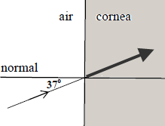
- $ŋ=\frac{\sin{i}}{\sin{r}}$ $\frac{\sin{37}}{\sin{27}}$ $ŋ$ = 1.33

- Both media have the same refractive index so the light ray doesn’t bend.

- Because the cornea has the same refractive index as water (1.33), therefore light doesn’t bend as it passes from water into the cornea.

- Because light which hits the cornea is now entering the cornea from air and therefore will refract so the cornea will once again act as a lens.

Revision question: 2019 Question 11 [Ordinary Level]

- The eye can focus light from both nearby and distant objects. Describe how the eye changes to allow this to happen.
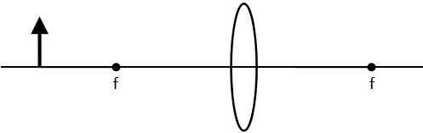
- Name the two most common eye defects.
- What type of lens corrects short sightedness? Draw a sketch of this lens.
- Copy the diagram into your answerbook and complete the ray diagram to form a real image.
- The power required to clearly view a nearby object is 38 m^{‐1}.
A person with an eye defect has a maximum power of 32 m^{‐1}.
Calculate the power of the lens required to correct this defect.
- What is the focal length of this lens?
Solution
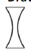
- The lens changes shape
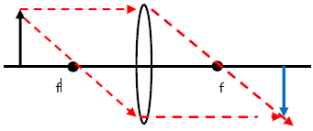
- Short sightedness and long sightedness
- diverging/ concave lens See diagram
- See diagram
- P_{corrected eye} = 38 m^{‐1} P_{defective eye} = 32 m^{‐1}
P_{corrected eye} = P_{defective eye} + P_{corrective lens}
P_{corrected eye} = P_{defective eye} + P_{corrective lens}
38 = 32 + P_{corrective lens}
P_{corrective lens} = 6 m^{‐1}

- $f=\frac{1}{P}=\frac{1}{6}$ m = 0.167 m

MEASUREMENT OF THE FOCAL LENGTH OF A CONVEX LENS

APPARATUS
Converging lens, screen, lamp-box with crosswire, metre stick, retort stand.

DIAGRAM

PROCEDURE
First find an approximate value for the focal length.
- Focus the image of a distant object onto a screen.
- Measure the distance between the lens and the screen.
This corresponds to an approximate value for the focal length of the lens.

- Place the ray-box well outside the approximate focal length.
- Move the screen until a clear inverted image of the crosswire is obtained.
- Measure the distance u from the crosswire to the lens, using the metre stick.
- Measure the distance v from the screen to the lens.
- Repeat this procedure for different values of u.
- Calculate the focal length of the lens each time using the formula and get an average.

RESULTS
Object distance u

Image distance v

Focal Length f

SOURCES OF ERROR / PRECAUTIONS
- Determining when the image was in sharpest focus; repeat each time and get an average.
- Parallax error associated with measuring u and v; ensure your line of sight is at right angles to the metre stick.
- Take all measurements from the centre of the lens.

Theory questions

Draw a labelled diagram of the apparatus that you used in the experiment. | Include a metrestick.
Describe, with the aid of a labelled diagram, how the student obtained the data.

How did the student find an approximate value for the focal length of the lens? | Focus the image of a distant object on a screen.  The distance from the lens to screen corresponds to the focal length.
What was the advantage of finding the approximate value of the focal lens? | To avoid placing object inside f during the experiment) which would have meant that the image couldn’t be formed on the screen.  OR so a real image could be formed
Describe, with reference to the diagram, how the student found the position of the image. | We kept the ray-box and the lens fixed and moved the screen until there was a clear image formed on the screen.
What measurements did you take? | We measured the distance from object (cross-wires) to the lens (u) and the distance from the lens to the screen (v).
How did you get a value for the focal length of the converging lens from your measurements? | By substituting the values for u and v into the formula .
Why is it difficult to measure the image distance when the object distance is less than 10 cm? | Image is virtual / image on same side as object / no image formed on screen
Why is it difficult to measure the image distance accurately? | Difficult to locate sharp image / centre of lens
Give two precaution that you took to get an accurate result. | Ensure that the crosshairs are in focus, repeat and find the average, avoid error of parallax  Measure from the centre of the lens (to the screen) / measure perpendicular distance /
Give two sources of error in measuring the image distance and state how one of these errors can be reduced.

Related exam questions
HL: 2012, 2009, 2003 OL: 2005

2009
A student was asked to measure the focal length of a converging lens. The student measured the image distance v for each of three different object distances u.
u/cm | 20.0 | 30.0 | 40.0
v/cm | 65.2 | 33.3 | 25.1
The student recorded the following data.
- Describe how the image distance was measured.
- Give two precautions that should be taken when measuring the image distance.
- Use all of the data to calculate the focal length of the converging lens.
{Answer: f = 15.3 cm, 15.8 cm, 15.4 cm f_{ave} = (15.5 ± 0.4) cm}

- What difficulty would arise if the student placed the object 10 cm from the lens?

2003
The following is part of a student’s report of an experiment to measure the focal length of a converging lens.
“I found the approximate focal length of the lens to be 15 cm.
u/cm | 20.0 | 25.0 | 35.0 | 45.0
v/cm | 66.4 | 40.6 | 27.6 | 23.2
I then placed an object at different positions in front of the lens so that a real image was formed in each case.” The table shows the measurements recorded by the student for the object distance u and the image distance v.

- How did the student find an approximate value for the focal length of the lens?
- Describe, with the aid of a labelled diagram, how the student found the position of the image.
- Using the data in the table, find an average value for the focal length of the lens.
{Answer: f = 15.4 cm, 15.5 cm, 15.4 cm, 15.3 cm f_{ave} = (15.4) cm}

- Give two sources of error in measuring the image distance and state how one of these errors can be reduced.

2012
u/cm | 12.0 | 18.0 | 23.6 | 30.0
v/cm | 64.5 | 22.1 | 17.9 | 15.4
In an experiment to measure the focal length of a converging lens, a student measured the image distance v for each of four different values of the object distance u.
The table shows the data recorded by the student.

- Describe, with the aid of a labelled diagram, how the student obtained the data.
- Why is it difficult to measure the image distance accurately?
- Using all of the data in the table, find the value for the focal length of the lens.
- Why is it difficult to measure the image distance when the object distance is less than 10 cm?

- How did the student find an approximate value for the focal length of the lens?
- Describe, with the aid of a labelled diagram, how the student found the position of the image.
- Using the data in the table, find an average value for the focal length of the lens.
{Answer: Average f = 10.0 ± 0.2 cm }
- Give two sources of error in measuring the image distance and state how one of these errors can be reduced.

Alternative (graphical method):
1/u | 0.050 | 0.033 | 0.025
1/v | 0.0153 | 0.0300 | 0.0398
Inverse values for u and for v
Plot points
Read intercept(s)
f = (15.87 ± 0.40) cm

SLOP

Draw a ray diagram to show how an erect image is formed by a magnifying glass. | See notes
A diverging lens cannot be used as a magnifying glass. Explain why. | The image is always diminished
Draw a labelled diagram showing the optical structure of the eye. | See notes
How does the eye bring objects at different distances into focus? | It can change the shape of the lens which in turn changes the focal length of the lens.
Give a common use for a convex lens. | Magnification, (eye) glasses, binoculars, contact lenses, camera, etc.
Name the part of the eye where an image is formed. | The retina
What is the function of the retina? | Light sensitive screen at the back of the eye
What is the function of the cornea? | Together with the lens, form part of the focusing system
What is the function of the optic nerve? | Carries the information in electrical form to the brain
What is the function of the iris? | Acts like a shutter to control the amount of light entering the eye
The eye can focus light from both nearby and distant objects. Describe how the eye changes to allow this to happen. | The lens changes shape which changes the power of the eye.
Name the two most common eye defects. What type of lens corrects short sightedness? | A diverging (concave) lens
What eye defect can be corrected using converging lenses? | Long sightedness?
Draw a labelled diagram showing the optical structure of the eye. | See notes
Draw a ray diagram to show the formation of a real image in a converging lens. | See notes
Draw a ray diagram to show the formation of a virtual image in a converging lens. | See notes
Draw a ray diagram to show the formation of a virtual image in a diverging lens. | See notes
A converging lens is used as a magnifying glass.  Draw a ray diagram to show how an erect image is formed by a magnifying glass. | See notes
A lens has a power of +50 m⁻¹. What type of lens is it and what is its focal length? | P = 1/f ⇒ f = 1/P = 1/50 = 0.02 m.  = 2 cm.
The power of a normal eye is +60 m⁻¹. A short-sighted person’s eye has a power of +65 m⁻¹.  Calculate the power of the contact lens required to correct this defect. | P_{Total} = P₁ + P₂  60 = 65 + P₂  Power = - 5 m
The power of an eye when looking at a distant object should be 60 m^{–1}. A person with defective vision has a minimum power of 64 m^{–1}. | P = P₁ + P₂  ⇒ 60 = 64 + P₂  ⇒ P₂ = -4 m⁻¹
A concave lens has a power of 0.1 cm⁻¹. What is the focal length of the lens? | P = 1/f ⇒ f = 1/P = 1/0.1 = 10 cm.
Two converging lenses, each with a focal length of 10 cm, are placed in contact. What is the power of the lens combination? | P₁ = 1/f₁ = 1/0.1 = 10 m⁻¹  P₂ = 10 m⁻¹  P = P₁ + P₂ = 20 m⁻¹

Exam questions Lenses 2002 – 2023

Ordinary level
2023 Question 8
- Refraction occurs when light travels through a lens.
Draw a converging lens and draw a ray diagram to show how the lens forms a real image.
- An object is placed 25 cm in front of a converging lens of focal length 15 cm.
Calculate the position of the image formed.
- Converging lenses can be used in glasses to correct a sight defect. Which sight defect is corrected using a converging lens?

2019 Question 11 [Ordinary Level]
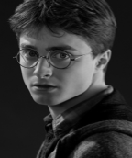
Read the following passage and answer the questions below. One of the most common sights anywhere in the world are eyeglasses. Since we depend so much on the lenses inside those frames to improve our view of the world, you might wonder just what goes into creating them. On the back of your eye is a complex layer of cells known as the retina. When you look at an object, an image is formed on the retina.
The retina reacts to light and conveys that information to the brain. To do all that, the eye has a lens between the retina and the pupil and a transparent covering called the cornea.

The pupil allows light to enter the eye. The lens, the ciliary muscles and the cornea work together to focus the image onto the retina. The lens has a different power depending on whether the object being viewed is nearby or far away. Sometimes the eye doesn't focus quite right. Most vision problems occur when the eye cannot focus the image onto the retina. The most common problems associated with the eye are as follows:
Myopia (short sightedness) occurs when a distant object looks blurred. Short sightedness is corrected with a diverging lens. Hyperopia (long sightedness) occurs when a nearby object looks blurred. Long sightedness is corrected with a converging lens. Placing the correct type and power of lens in front of the eye compensates for the eye's inability to focus the image on the retina.
Adapted from https://science.howstuffworks.com/innovation/everyday‐innovations/lens6

- Name the part of the eye where an image is formed.
- What is the function of the pupil?
- The eye can focus light from both nearby and distant objects. Describe how the eye changes to allow this to happen.
- Name the two most common eye defects. What type of lens corrects short sightedness?
- Draw a sketch of this lens.
- Copy the diagram below into your answerbook and complete the ray diagram to form a real image.

- The power required to clearly view a nearby object is 38 m^{‐1}.
A person with an eye defect has a maximum power of 32 m^{‐1}.
Calculate the power of the lens required to correct this defect?
What is the focal length of this lens?
- Light undergoes refraction as it passes through a lens. What is meant by refraction?

2020 Question 7 [Ordinary Level]
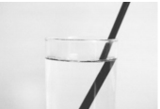
Light undergoes refraction as shown in the picture.
Refraction is the bending of light as it passes from one medium into another.
- State Snell’s law of refraction.
- Describe an experiment to demonstrate Snell’s law.
- A beam of light travelling from air strikes the surface of water.
The angle of incidence is 36° and the angle of refraction is 26°.
Use Snell’s law to calculate the refractive index of water.
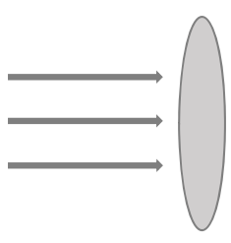
- Refractive index can also be calculated using the formula $n=\frac{1}{\sin{C}}$
What does C stand for in the formula written above?
- A converging lens refracts light.
Copy and complete the diagram below to show the paths of the rays of light after they strike the converging lens.
- A converging lens can be used to produce a magnified virtual image.
Explain the underlined term.
- A converging lens has focal length 15 cm (f = 15 cm).
An object is placed 20 cm in front of the lens (u = 20 cm).
Calculate the image distance, v.

- Calculate the magnification, m.
- State one use of a lens.

2022 Question 14 (b) [Ordinary Level]

In order for an observer to see a mirage on a hot day, total internal reflection must occur. Mirages happen when the ground is very hot and the hot air just above the ground and the cool air higher up have different refractive indices.
Light undergoes refraction as it travels from the cool air into the hot air.
- Describe an experiment to demonstrate total internal reflection.

To see an object clearly, light from an object must enter the eye through the pupil and come to focus on the retina at the back of the eye.
The eye focusses the light onto the retina.
If the light from a distant object comes to focus in front of the retina, the person will see a blurred image. This person is said to be short sighted.
- What type of lens is used to correct short sightedness?

A certain person’s eye has a power of 62 m^{–1}.
The lens of their glasses has a power of –2 m^{–1}.
- Calculate the power of the combination of the eye and the lens.
- Calculate the focal length of the lens in the glasses.

Higher level

2021 Question 14 (d) [Higher Level]
Ball lenses are glass spheres which can be used for special effects in photography.

Light travels at a different speed in air and in glass.
- The photograph shows the inverted image of a mountain formed in a ball lens.
Draw a ray diagram to show how an inverted image is formed in a lens.
- Is the image real or virtual?
- The critical angle of the glass in a ball lens is 41.4°.
What is meant by critical angle?
- Calculate the speed of light in the ball lens.
- Explain why white light is dispersed as it passes through the ball lens.

2015 Question 12 (b) [Higher Level]
- When light passes through a lens, it is refracted at both faces of the lens.
Copy the diagram on the right into your answer book and complete the path of the light ray through the section of the lens. Include the normal at both faces.
- Draw a ray diagram to show the formation of a virtual image in a converging lens.
- A converging lens of focal length 20 cm and a diverging lens of focal length 8 cm are placed in contact.
Calculate the power of the combination.
- What eye defect can be corrected using converging lenses?

2002 Question 12 (b) [Higher Level]
- State the laws of refraction of light.
- Draw a labelled diagram showing the optical structure of the eye.
- How does the eye bring objects at different distances into focus?
- The power of a normal eye is +60 m⁻¹. A short-sighted person’s eye has a power of +65 m⁻¹.
Calculate the power of the contact lens required to correct the person’s short-sightedness.
- Calculate the focal length of the contact lens required to correct the person’s short-sightedness.

2006 Question 7 [Higher Level]
- What is meant by the refraction of light?
- A converging lens is used as a magnifying glass.
Draw a ray diagram to show how an erect image is formed by a magnifying glass.
- A diverging lens cannot be used as a magnifying glass. Explain why.
- The converging lens has a focal length of 8 cm.
Determine the two positions that an object can be placed to produce an image that is four times the size of the object?
- The power of an eye when looking at a distant object should be 60 m^{–1}.
A person with defective vision has a minimum power of 64 m^{–1}.
Calculate the focal length of the lens required to correct this defect.
- What type of lens is used?
- Name the defect.

2008 Question 9 [Higher Level]
- What is meant by refraction of light?
- State Snell’s law of refraction.

An eye contains a lens system and a retina, which is 2.0 cm from the lens system.
The lens system consists of the cornea, which acts as a fixed lens of power 38 m^{–1}, and a variable internal lens just behind the cornea. The maximum power of the eye is 64 m^{–1}.
- Calculate how near an object can be placed in front of the eye and still be in focus;
- Calculate the maximum power of the internal lens.

- Light is refracted as it enters the cornea from air as shown in the diagram.
Calculate the refractive index of the cornea.
- Draw a diagram to show the path of a ray of light as it passes from water of refractive index 1.33 into the cornea.
A swimmer cannot see properly when she opens her eyes underwater. When underwater:
- Why does the cornea not act as a lens?
- What is the maximum power of the eye?
- Why do objects appear blurred?
- Explain how wearing goggles allows objects to be seen clearly.

Exam solutions 2002 - 2022: Ordinary level maths parts only

2003 Question 7 [Ordinary Level]
Calculate the refractive index of the glass.
n = 1/sin C ⇒ n = 1/ sin 42 ⇒ n = 1.5

2004 Question 12 (b) [Ordinary Level]
How far from the mirror will the image be formed?
⇒ 1/20 = 1/30 + 1/v ⇒ v = 60 cm

2005 Question 7 [Ordinary Level]
Calculate a value for the refractive index of the glass.
$n=\frac{1}{\sin{c}}= \frac{1}{\sin{41.8}}=\frac{1}{0.67}$ ⇒ 1.5

2014 Question 8 [Ordinary Level]
In the diagram the value of the angle i is 38⁰.
Calculate the value of the refractive index of the glass.
$$n=\frac{1}{\sin{c}}= \frac{1}{\sin{38}}=1.62$$
2017 Question 7 last part [Ordinary Level]
An optical fibre cable has a refractive index of 1.5.
Calculate the angle at which total internal reflection occurs.
$n_{g}=\frac{1}{\sin{C}}$ $\sin{C}=\frac{1}{n_{g}}$ $\sin{C}=\frac{1}{1.5}$ $\sin{C}=0.66$ $C=\sin^{-1}{0.66}$ C = 41.8⁰

2019 Question 11 [Ordinary Level]
The power required to clearly view a nearby object is 38 m^{‐1}.
A person with an eye defect has a maximum power of 32 m^{‐1}.
Calculate the power of the lens required to correct this defect?
What is the focal length of this lens?
P = 38 – 32 = 6 m^{‐1}
$f=\frac{1}{P}=\frac{1}{6}$ m = 0.167 m

2020 Question 7 [Ordinary Level]
Use Snell’s law to calculate the refractive index of water.
$n=\frac{\sin{36}}{\sin{26}}$ = 1.34

Calculate the image distance, v.
$\frac{1}{f}=\frac{1}{u}+\frac{1}{v}$ $\frac{1}{v}=\frac{1}{f}-\frac{1}{u}$ $\frac{1}{v}=\frac{1}{15}-\frac{1}{20}$ $\frac{1}{v}=\frac{1}{60}$ v = 60 cm
Calculate the magnification, m.
$m=\frac{v}{u}=\frac{60}{20}$ magnification = 3

2021 Question 10 [Ordinary Level]
An object of height 2 cm is placed 17 cm in front of a concave mirror.
An image with a height of 3 cm is formed

Calculate the magnification.
$M= \frac{v}{u}=\frac{3}{2}$
Calculate the image distance.
$M= \frac{v}{u}$ v = Mu v = (1.5)(17) = 25.5 cm

2022 Question 9 [Ordinary Level]
The object is 20 cm in front of the concave mirror. The mirror has a focal length of 12 cm.
Calculate the position of the real image formed.
1/u + 1/v = 1/f
v = 30 cm
The object has a height of 4 cm. Calculate the height of the image.
m = v/u = 1.5
image height = 4 × 1.5 = 6 cm

2022 Question 14 (b) [Ordinary Level]
A certain person’s eye has a power of 62 m^{–1}.
The lens of their glasses has a power of –2 m^{–1}.
Calculate the power of the combination of the eye and the lens.
P = 62 + (–2) = 60 m^{–1}

Calculate the focal length of the lens in the glasses.
$f=\frac{1}{P}$ $f=\frac{1}{2}$= 0.5 m

Did you realise that when you are looking at the person beside you, you don’t see them as they are, but as they were a fraction of a second ago? This is because it took time for the light which is entering your eye to travel from your friend to you. Similarly it takes eight minutes for light from the sun to reach the earth, so when you look at the sun you don’t see it as it is now but rather as it was eight minutes ago - you are therefore looking back in time! Now if you look up at the night sky you can see objects which are so far away that it has taken light millions of years to reach us. Some of these objects may well have exploded a million years ago yet it may be another million years before we notice it. So when some of this light left its star, humans had not even appeared on Earth. Back to the sun: it may very well have exploded 7 ½ minutes ago but the first you will know about it will be in 30 seconds time. At which stage you will possibly only have minutes to live. 29, 28, 27 . . .
A mirror may be made of glass but the glass actually plays little if any role in the image formation. It only exists to prevent the reflective part of the mirror (usually silver oxide) from oxidising (rusting). have noticed that you can sesome light reflects off the glass instead of passing through it – this is because no glass isperfectly transparent to light. Can you use this information to help explain why when it’s dark outside but bright inside (you’ve got the light on) you can see your reflection in the window?
Terminology The normal is an imaginary line perpendicular to the surface of the mirror originating at the point of intersection between the incident ray and the mirror. A plane is a two-dimensional surface (like the surface of a page) so if you imagine the incident ray travelling along the surface of this page until it strikes the mirror, the reflected ray will also travel along the surface of this page (so it won’t reflect up off the page or down into the page). Physics is awash with terms like this which mean one thing in everyday parlance but something completely different in a physics context. See example below: Exam Question: What can you see in a plane mirror? Student answer: Rows of seats and the wings
The angle of incidence is the angle between the incident ray and the normal (not the mirror), and the angle of reflection is the angle between the reflected ray and the normal. If we defined the angle of incidence to be the angle between the incident ray and the mirror we could run into difficulties if the surface of the mirror was not perfectly smooth (see diagram above).
This term doesn’t make any sense until we are in a position to contrast it with the image formed in curved mirrors so for now you just need to remember the term.
When drawing the diagram it is very useful to ‘cheat’ and put the image the same distance behind the mirror as the object is in front before you do anything else. This should now make the diagram a lot more accurate, and lo and behold, when you’re finished the image will be the same distance behind the mirror as the object is in front! You’re not likely to get asked to do this in an exam but it is a useful exercise in that it helps you to appreciate how it all comes together.
Alternatively, look out the window at dusk; you can see the light bulb from your room seemingly hanging outside in mid-air. You can extend this and get a collegue to go outside and stand ‘under’ the lightbulb, then measure the distance from colleague to the window; it will match the actual distance from bulb to window inside the room.
History of science snippet We have already mentioned that the idea of how we know ‘where’ the object is in relation to its surroundings is rarely dealt with in textbooks. In fact it is a question that puzzled observers for well over 1000 years. Ibn al-Haytham (aka Alhazen) born in what is now Iraq is regarded as the father of modern optics. He investigated not only the reflection of light but also visual perception and even believed that "seeing" involves much more than just formation of images on the back of the eye. He was possibly the first to realise that the angle at which the ray entered the eye was relevant. The role of non-western contributions to the development of science has traditionally been ignored by both historians of science and textbook authors but this is (very) slowly changing, as is recognition of the role of female scientists. Alhazen's Neglected Discoveries of Visual Phenomena: Link Ibn al-Haytham's ground theory of distance perception: Link Perception as Unconscious Inference Gary Hatfield: Link
Advice for drawing ray diagrams: - Put a very slight curvature on the mirror to begin with, or better still make the mirror a straight line while drawing the rays and only afterwards put in a slight curve. - Put arrows on all rays – do this for all the images below - State whether the image is real or virtual, upright or inverted, magnified or diminished
The fact that a real image can be formed on a screen isn’t just something to be learned ‘off by heart’, you really should try this for yourself in school or even at home using a cosmetic mirror to focuses the image of a distant object onto a white page. It’s even more impressive if you use a lens, the physics of which we study in a later chapter. I emphasise this here because it is likely to be the first of many ‘wow’ moments over the next two years, as it (ever so) slowly dawns on students that physics is actually interesting (doing this with a coloured image brings an even greater sense of wonder). Or go one step farther and view a real image sitting in the air using what’s called a ‘Magic Mirror’ – see image above. Purchase on amazon or at the very least see it in action on YouTube.
We first mentioned virtual images when we were looking (sorry) at plane mirrors and I mentioned that you really weren’t in a position to appreciate the meaning until we were able to contrast them with real images. Once again, virtual images represent your brain being fooled. Your brain assumes that light always travels in a straight line and doesn’t take into account that the rays were reflected from a mirror en route.
For applications 1 – 3 above the light bulb is placed at the focus; this means that all light going backwards from the bulb hits the mirror and gets reflected back out parallel to the principal axis instead of spreading out in all directions. Solar mirrors are a slight variation on this; light rays coming from the sun are travelling approximately parallel to the principle axis and so all reflect back through one point - the focus. If you put a container of water here you can get the water to boil if it’s in strong sunlight.
Cosmetic mirrors – your face needs to be inside the focus in order to produce an image which is magnified and upright. This one completely blows my mind. Our brain is being fooled into thinking that the object is bigger than it actually is, but the outcome is that we can see the image better (because its magnified) than if it wasn’t being fooled. You couldn’t make this up. And anyway even using the term ‘your brain’ is quite odd. Is it your brain that is being fooled – or is it you? And if there’s a difference what is it?
Be careful suing this rule – ideally you should use a protractor to make sure that the angle of reflection = equals angle of incidence. If you are just using guesswork you may end up with two rays of light which converge under the principle axis (suggesting an inverted image) instead of above it.
"Philosophy is written in that great book which ever lies before our eyes — I mean the universe — but we cannot understand it if we do not first learn the language and grasp the symbols, in which it is written. This book is written in the mathematical language, and the symbols are triangles, circles, and other geometrical figures, without whose help it is impossible to comprehend a single word of it; without which one wanders in vain through a dark labyrinth.” Galileo Galilei (translated quote) as mentioned in Il Saggiatore (1623). Galileo. Note that Galileo makes no reference to algebra. That came later. “God is a mathematician of a very high order, and He used very advanced mathematics in constructing the universe.” Paul Dirac (1902-1984). Dirac was awarded a Nobel Prize for predicting anti-matter. We will come back to this next year.
Which is the object distance, U or V? Remember that U comes before V in the alphabet, and you need an object before you can have an image, so U = object distance and V = image distance.
Or think I = AM where I is image size, A is actual size of the object and M is the magnification factor.
You will often see the phrase ‘when light goes from a more dense to a less dense medium’ because if one medium has a higher refractive index than another then it is also likely to be more dense - but not always. For example the refractive index of many oils is greater than the refractive index of water, but oil is less dense than water. The term ‘optically dense’ is often used to get around this. Similarly light won't bend just because it's passing from one medium to another – the media have to have different refractive indices. There was a nice exam question a few years back on light passing from water into the cornea of the eye and therefore not experiencing refraction because they have the same refractive index.
Snell’s Law trivia #1: The law of refraction was first accurately described by Ibn Sahl of Baghdad in 984. trivia #2: In French, Snell's Law is called "la loi de Descartes" or "loi de Snell-Descartes" because the French philosopher/mathematician/scientist came up with the law independently in 1637 (Snell devised his version in 1621). Not trivia: each colour of light has its own wavelength, and the refractive index of each wavelength is slightly different. So when we say that the refractive of glass is (for example) 1.5, we mean as an average of all colours (or wavelengths) that make up white light. We re-visit this in an exam question (2022 Deferred Higher Level) later in this chapter.
Irishman John Tyndall from County Carlow was one of first to investigate fibre optics, and demonstrated it using a water fountain. Tyndall was one of the foremost scientists in Britain in the mid to late 1800’s and did a lot of pioneering work on optics. He was the first to explain properly why the sky is blue and why it gets red as the sun goes down. He was also a noted mountaineer. Never again ask why God invented Carlow. Scientists can now create glass that is so extraordinarily clear that if you created a block a half-mile long it would be as clear as a normal windowpane (without the birdpoop).
Of all the formulae related to refractive index, this is the most fundamental in that the reason light refracts in the first place is because it travels at different speeds in different media. The relationship between refractive index and the angles of incidence and refraction can only be derived by first considering the speed of the lightwave in the two media.
The fact that the speed of light doesn’t change (in a given medium) is such a bizarre concept that you couldn’t make it up. It took the genius of Albert Einstein to discover it and from there he went on to develop the theory of special relativity. By the way, why is "c" used for the speed of light? Possible from the Latin 'celeritas' meaning speed, as an alternative to v (used for speed of particles). However we now also use c to represent the speed of any wave and so it also is used for the speed of sound (even though the speed of sound is a paltry 340 m s⁻¹).
Our brains have not evolved to appreciate very big or very small numbers. Here’s one way to get a sense of positive powers of three: Byte of data: one grain of rice Kilobyte: cup of rice Megabyte: 8 bags of rice Gigabyte: 3 container lorries. Terabyte: 2 container ships
You should be able to draw a ray diagram showing how an image is formed by a convex lens when the object is placed - outside the focus – resulting in a real image - inside the focus – resulting in a virtual image
Not sure myself how this works but we’ll just roll with it for now.
Confusion with Mirrors and Lenses Whereas a concave mirror gives a real image (unless the object was inside the focus) this time it’s a convex lens which gives a real image (unless the object is inside the focus). Secondly, whereas with mirrors a virtual image was always formed behind the mirror, with lenses it’s a real image which is formed at the other side of the lens, and a virtual image is always formed on the same side of the lens as the object. After that however the chapter is remarkably similar to the chapter on spherical mirrors. Very cool activity Focus an image of a distant object (like a house or the sky if it’s a bright day) onto a screen (a white page) using lenses or mirrors. This is always impressive, particularly when you notice that the image is in colour, and upside down. The lens must be convex (converging), and the mirrors concave. Why?
We normally think that just the lens is responsible for refraction of light, but light refracts whenever it goes from a medium of one refractive index to another and the refractive index of the cornea is different to both the refractive index of air and the refractive index of the lens so refraction takes place at each of these interfaces. We will shortly be looking at exam questions where the person is underwater. It turns out that the refractive index of the cornea is approximately the same as the refractive index of water so in that context no refraction takes place – unless we’re wearing goggles. Refractive index of parts of the eye n _{cornea} = 1.37 n _{lens} = 1.42 n _{vitreous humour} = 1.336
Hopefully you now ‘see’ why our brain gets tricked so much. It’s a very complex world out there and all of that information from a fast-moving 3-D world gets smushed into a tiny 2-D area on the back of your eye (the retina) and once your brain receives that information it has to somehow work backwards with it and establish what the reality actually is. And it’s got to do all of this in real time. It’s not surprising that the brain uses a variety of shortcuts, or that it sometime gets ‘fooled’ via illusions. Overall it does a bloody good job so just be thankful for what you have.
Cheap sunglasses block visible light but not UV light. When it is dark (as a result of the sunglasses) our pupils expand to let in more light so more UV light gets through to the back of the eye. Hence the increases risk of melanoma. Link
Power of accommodation Hold these notes out at arm’s length and notice that you can still read them clearly. Now slowly bring the notes in until they are touching your nose. You can now no longer read them clearly. Why not? Answer As the screen or page gets closer to your eye the lens in your eye has to change shape to allow the light rays to intersect on your retina - it accommodates to give a clear image. For an object that is very close, the lens in your eye cannot curve sufficiently to enable the rays of light to intersect on your retina.
Opticians use the dioptre as the name of the unit of power but this is not used in the SI system.

